Supporting Figure 1: PCI utilization across HRRs across the entire country.

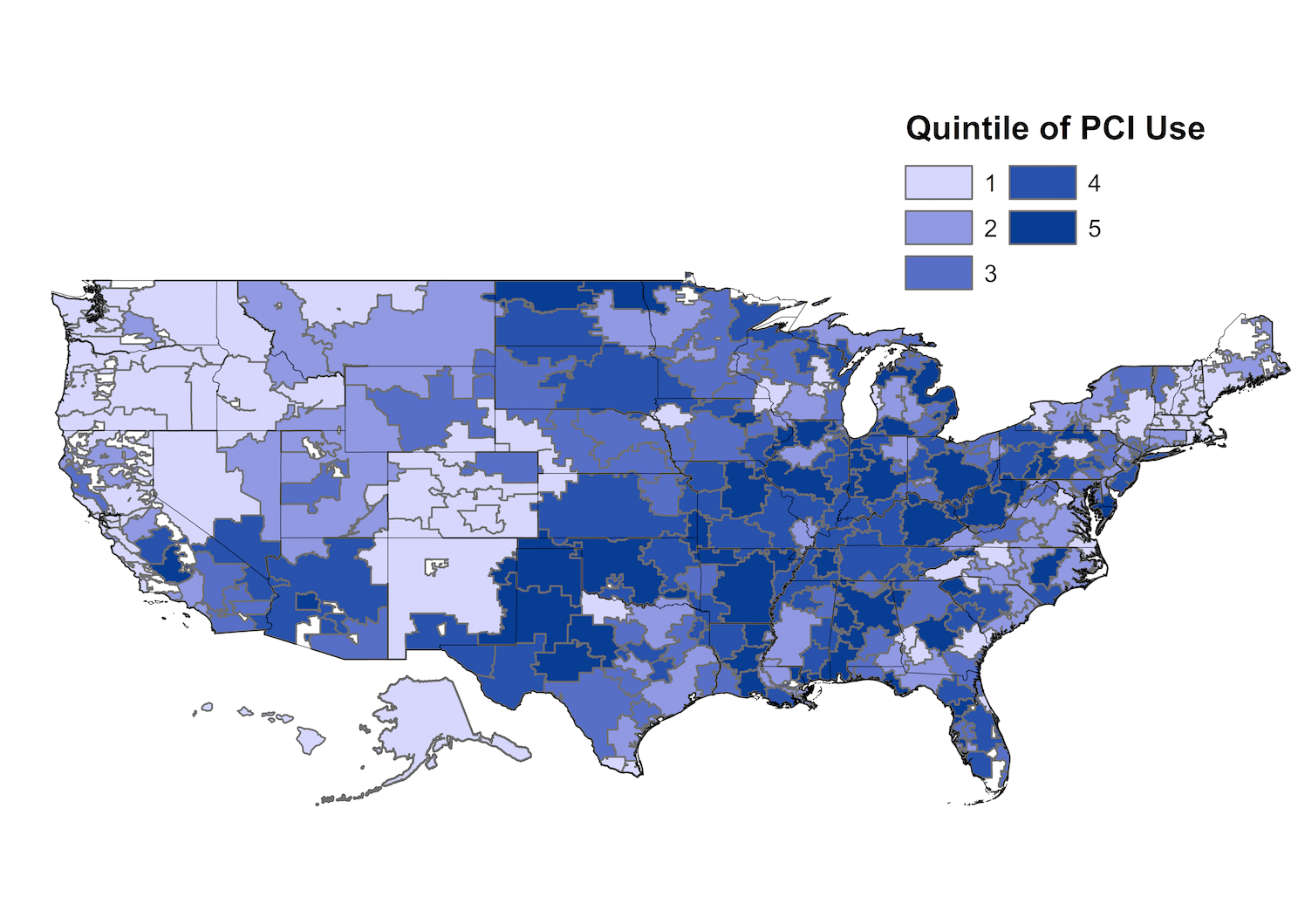

Caption: Shown is PCI utilization across all HRRs in the United States.

Abbreviations: PCI = percutaneous coronary intervention

