“Why do people donate to conservation? Insights from a ‘real world’ campaign” by Veríssimo et al. (2016) – Supporting Information

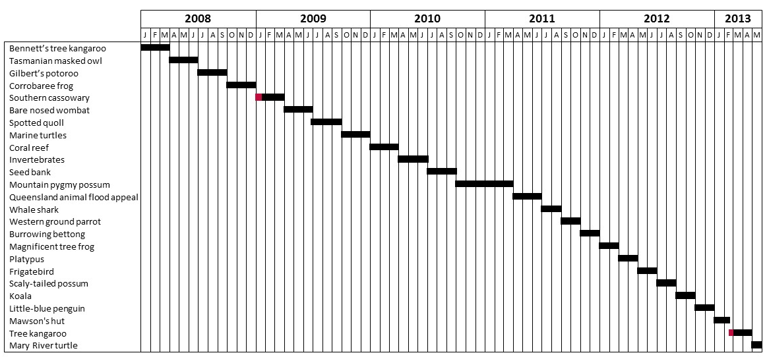

S1 Figure – Gantt chart illustrating in black the timeline of the fundraising campaigns by the Australian Geographic Society included in this study. Red bars indicate shorter ad hoc emergency fundraisers.

