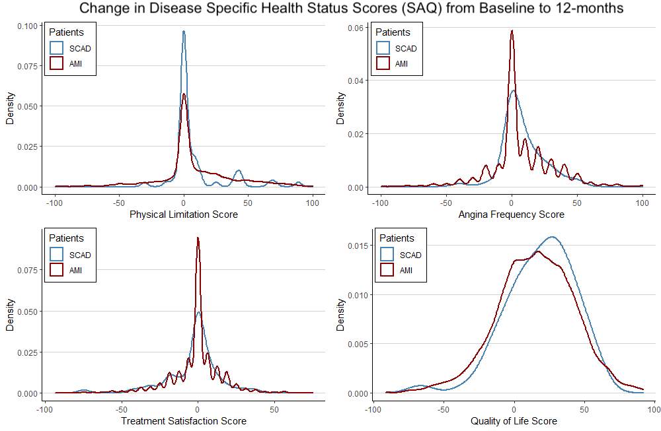
Supplementary Figure 2. Distribution of change in disease specific health status scores from baseline to 12-months for SCAD and other AMI patients. Density plots showing the distribution of change in disease specific health status scores from baseline to 12-months for SCAD and other AMI patients for the Seattle Angina Questionnaire (SAQ) health status measure (AMI=red, SCAD=blue). CVD indicates cardiovascular disease.

