S2. Sampling effort
All sites were sampled intensively with equal sampling effort (36±1h per site). It is extremely difficult to reach a rarefaction asymptote for interactions (Chacoff et al. 2012). In order to evaluate the sampling completeness of interactions across our sites in more detail, we used the method of Chao (1987), calculating the Chao 2 estimator of asymptotic species richness (using interactions instead of species):
S_{E} =S_{O} + (L²/2M),
where L is the number of interactions that occur in only one sample, M is the number of interactions that occur in exactly two samples, and S₀ is the observed number of unique interactions. Then, to estimate the percent asymptotic richness detected we calculated the ratio of S_{O} to S_{E} (Chacoff et al. 2012). The average percent asymptotic richness detected across sites was 58.13%, SD = 4.63 (55% detected by Chacoff et al. 2012 for comparison). Based on these calculations and visual inspection of the rarefaction curves, we argue that sites are adequately and, importantly for this study, equally well, sampled.
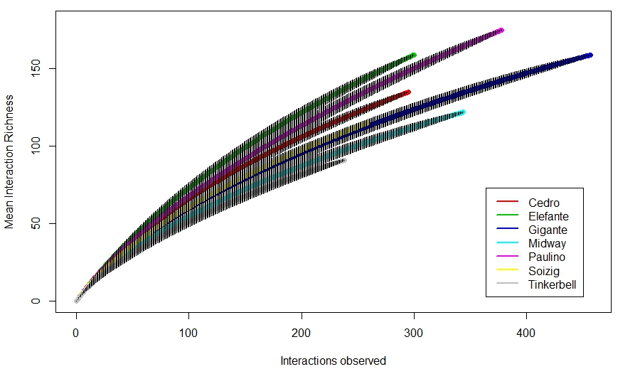
Site | Chao2 | Sampling time (min)
Gigante | 62.96 | 2190
Paulino | 54.55 | 2220
Tinkerbell | 64.56 | 2100
Midway | 61.30 | 2190
Cedro | 53.45 | 2130
Elefante | 55.19 | 2130
Soizig | 54.89 | 2190
Average | 58.13 | 2164
Chao A (1987) Estimating the population size capture-recapture data with unequal catchability. Biometrics 43: 783-791.
Chacoff NP, Vázquez DP, Lomáscolo SB, Stevani EL, Dorado J, et al. (2012) Evaluating sampling completeness in a desert plant-pollinator network. Journal of Animal Ecology 81:190-200.

