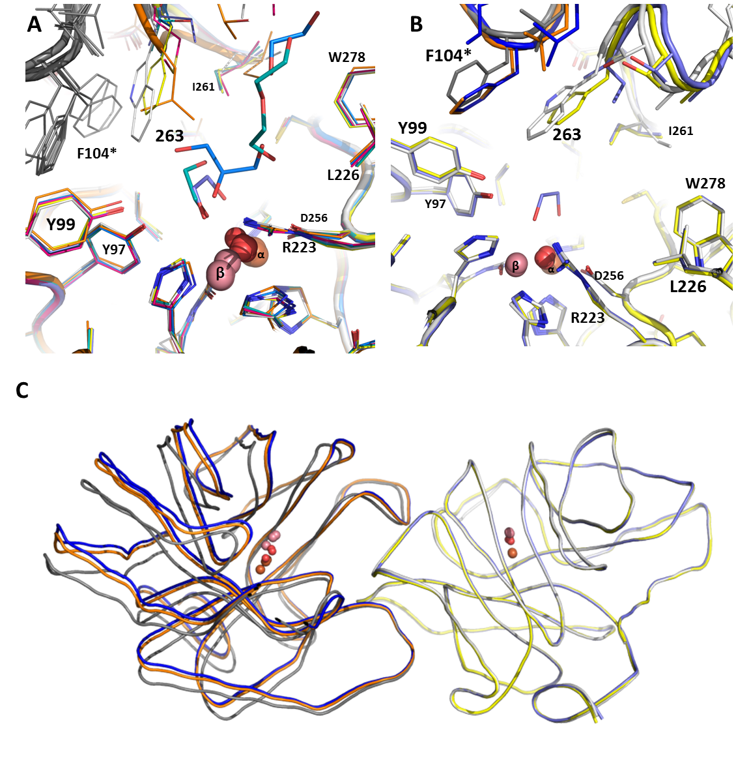
Figure S6: Structural comparisons of selected variants and wt SsoPox
A. Structural superposition of selected variants (V: blue; T: light blue; I: light violet; F: yellow; L: orange; M: pink) and wt SsoPox (light grey) at the active site region. The second monomer of each structure is represented in dark grey; the F104 of this second monomer is indicated with a star. B. Structural superposition of representing member of PteSV (SsoPox-W263F; first monomer: yellow; second monomer: orange), LacSV (SsoPox-W263I; first monomer: light violet; second monomer: dark blue) and wt SsoPox (first monomer: light grey; second monomer: dark grey) at the active site region. The F104 of the second monomer is indicated with a star. C. Structural comparison of dimer compaction with structural superposition of first monomer and observing impact on the second monomer of wt SsoPox, W263F and W263I (colour codes are the same as before).

