S4 Fig

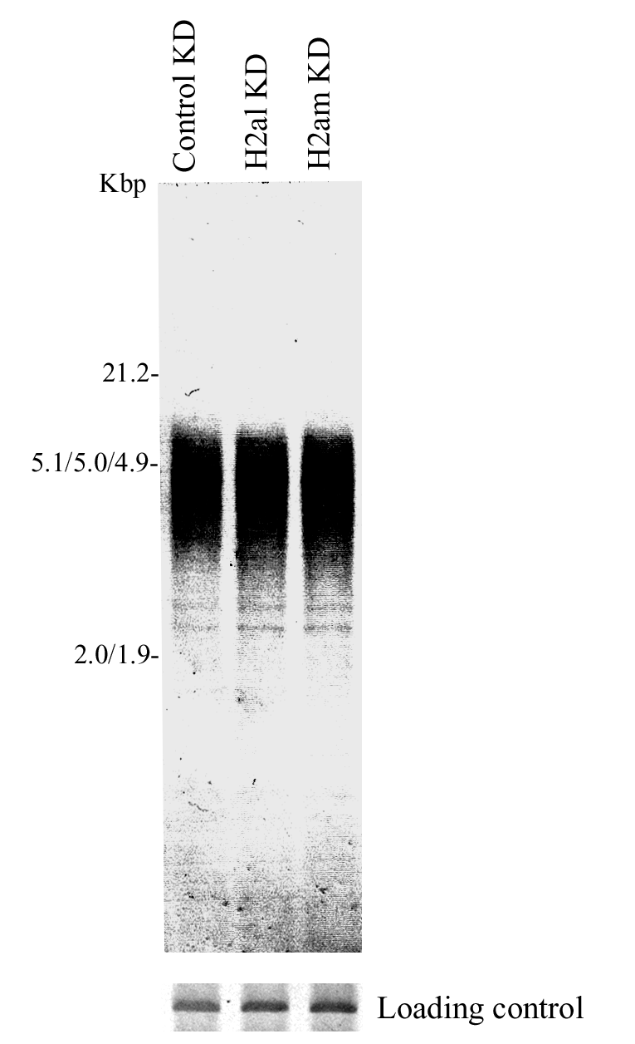

S4 Fig. TRF assay in MCF-7 treated with H2al or H2am siRNA. MCF-7 cells were harvested at day 5 after three separate transfections with control, H2al and H2am siRNAs. Telomere-repeat length and intensity was measured by restriction digest of genomic DNA with HinfI/RsaI and Southern hybridization with DIG-labeled (TTAGGG)₄ probe (top panel). The G3PDH region was used as a control for DNA loading (bottom panel). The position of MWs (kb) is indicated on the left.

