S2 Fig. Bivariate plot of daily loss of water vapor and egg mass in living species. Ordinary least square (OLS) and phylogenetic generalized least square (PGLS) regressions as well as the 95% confidence intervals (CIs) were conducted for living archosaur species using IBM SPSS Statistics v. 22.0.0 (IBM SPSS Inc.) and PDAP module v.1.15 [1] of the software Mesquite 3.02 [2]. For the phylogenetic approach, a phylogenetic tree of 196 species was reconstructed (S1 Fig.) and tree lengths were assigned based on Pagel's method [3] and divergence time. White and black dots represent open and covered nesters, respectively. Note that log M_{H2O} is strongly correlated with log M (r² = 0.888 for OLS, 0.638 for PGLS with Pagel's branch length method, and 0.670 for PGLS with the divergence time method).
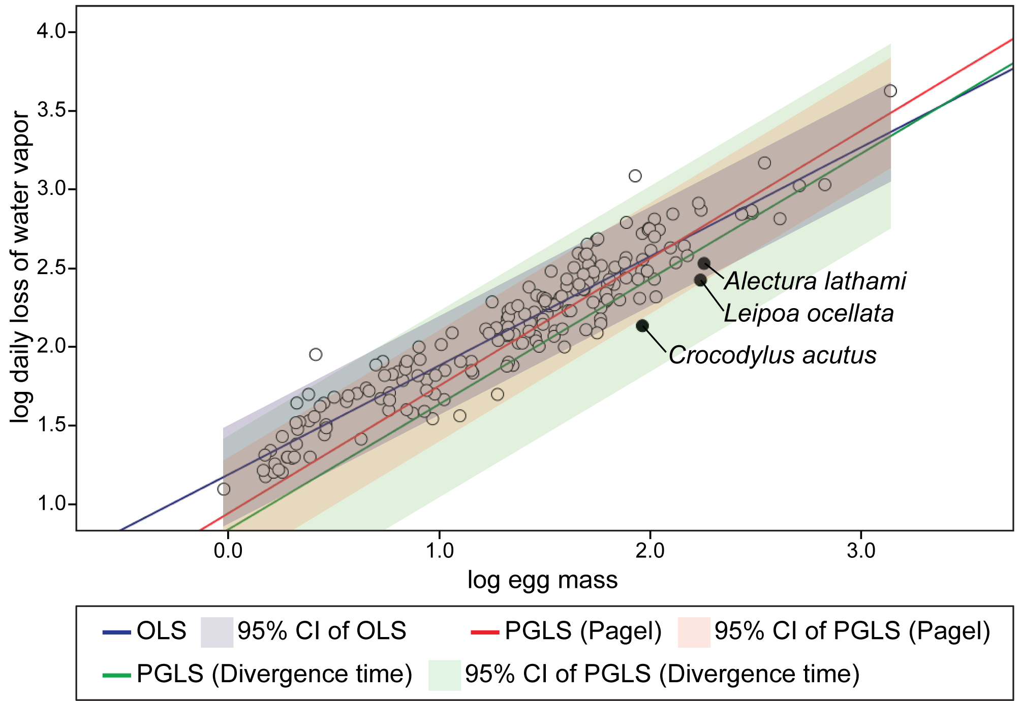

References
1. Midford PE, Garland Jr. T, Maddison WP (2010) PDAP package of Mesquite, version 1.15. See http://mesquiteproject.org/pdap_mesquite/index.html.
2. Maddison WP, Maddison DR (2010) Mesquite: a modular system for evolutionary analysis. Version 2.73. See http://mesquiteproject.org.
3. Pagel MD (1992) A method for the analysis of comparative data. Journal of Theoretical Biology 156: 431-442.

