- Bombus impatiens black hairs extracted in Na₂CO₃

- Bombus huntii orange and yellow hairs extracted in Na₂CO₃

- Dasymutilla occidentalis extracted in Na₂CO₃

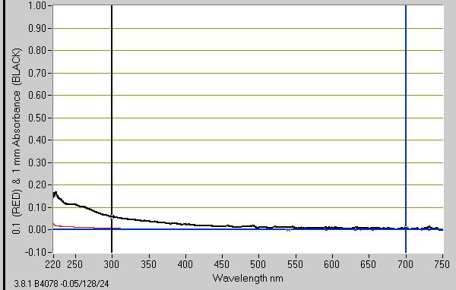
(D) Dasymutilla scitula S1 extracted in Na₂CO₃ S1

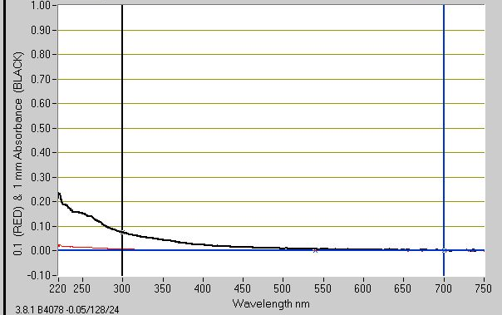
(E) Psorthaspis portiae P1 extracted in Na₂CO₃ P1

(F) Dasymutilla satanas extracted in Na₂CO₃

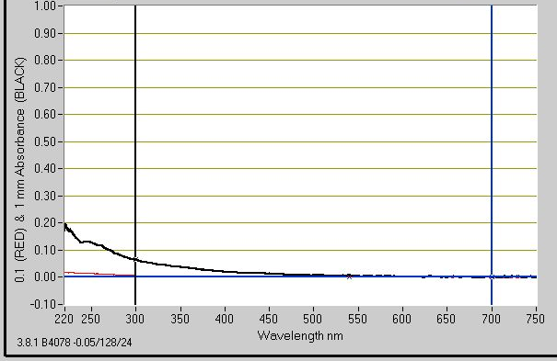
(G) Dasymutilla gloriosa G1 extracted in Na₂CO₃ G1

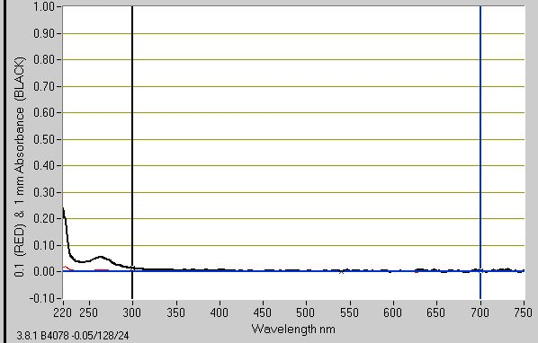
(H) Dasymutilla gloriosa G1 extracted in pH3 MeOH

