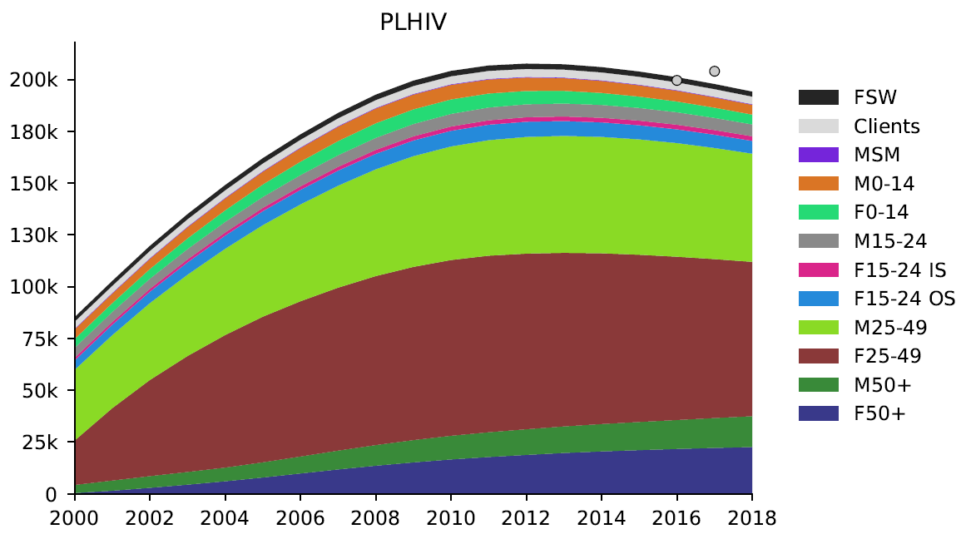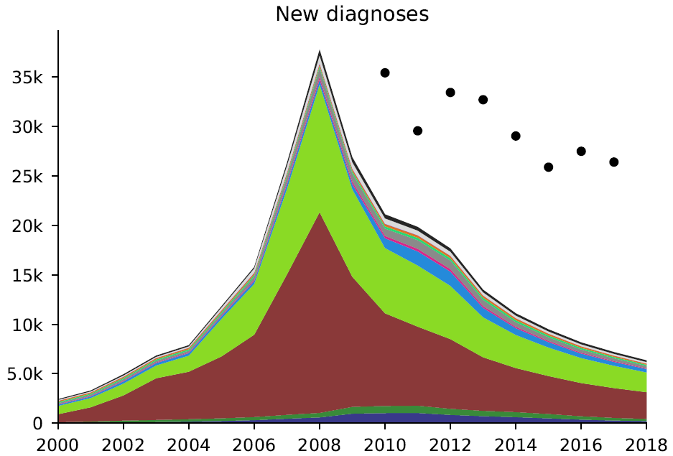
Year
Year
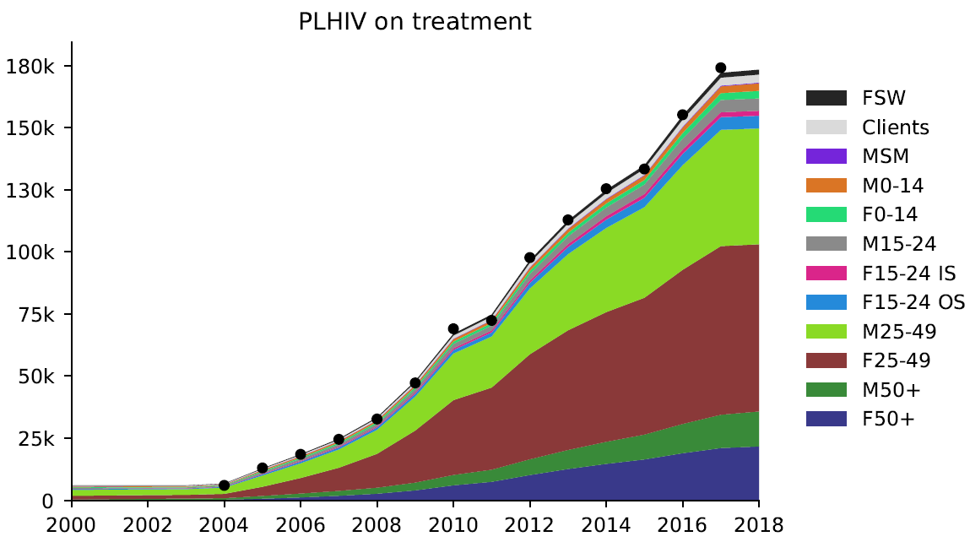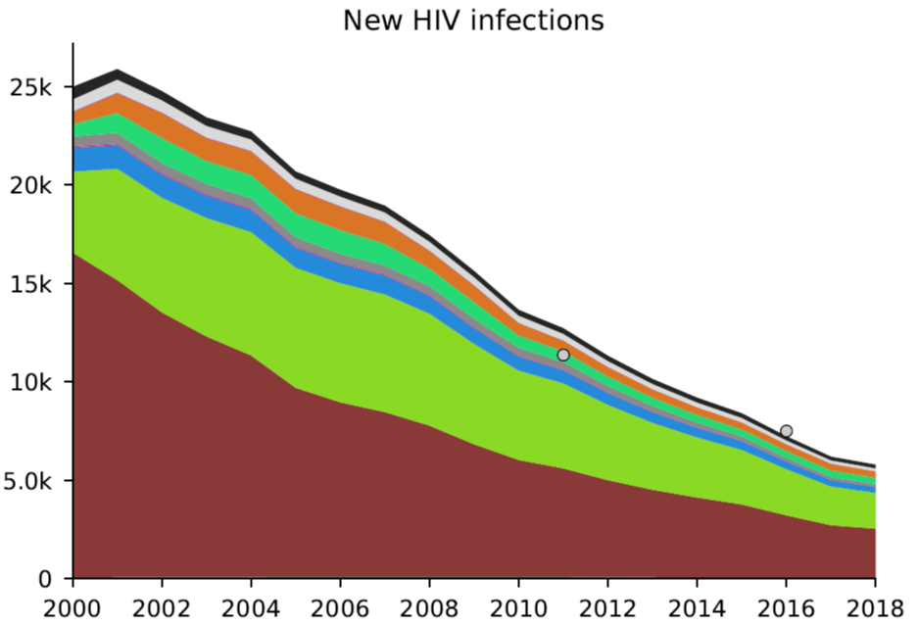
Year
HIV-related deaths
Year
New HIV infections
PLHIV on treatment
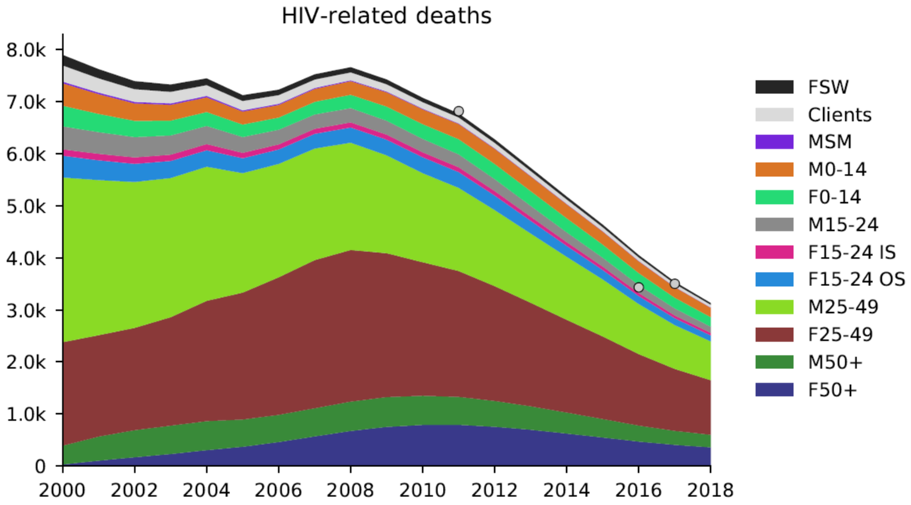
Year
Figure S1. Model calibration to people living with HIV (PLHIV), new HIV diagnoses, PLHIV on treatment, new HIV infections, and HIV-related deaths
Source: Optima HIV model, 2018

