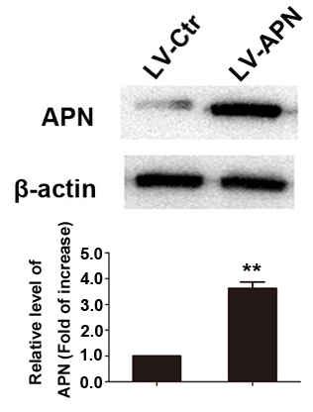
S2 File. Lentiviral vector-mediated APN overexpression was determined by western blot. (**, p < 0.01, n = 6 for each group).

