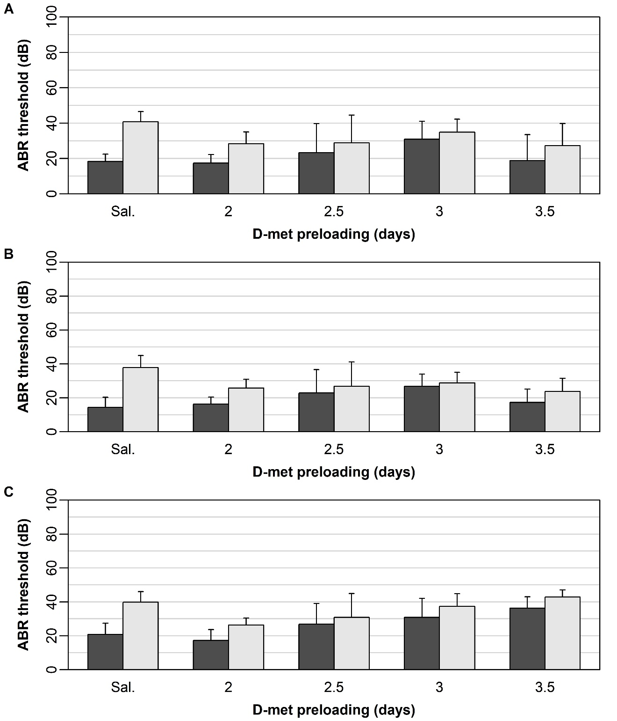
Figure S4: Mean (± one standard deviation) baseline and final ABR thresholds (dB) at frequencies of 8 (A), 14 (B), and 20 (C) kHz under steady-state noise exposure. Baseline (dark gray) and final (light gray) thresholds are shown for the control group (labelled ‘Sal.’) and all D-met preloading groups (2, 2.5, 3, and 3.5 days). Ten animals were tested in each group.

