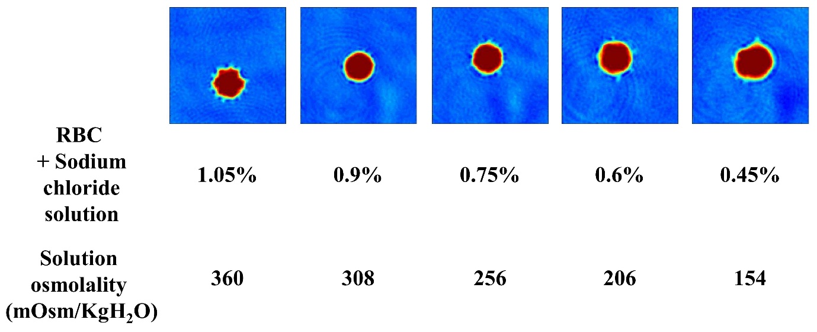

S2 Fig. 2D images of red blood cells in the sodium chloride solutions. RBC, red blood cell.

