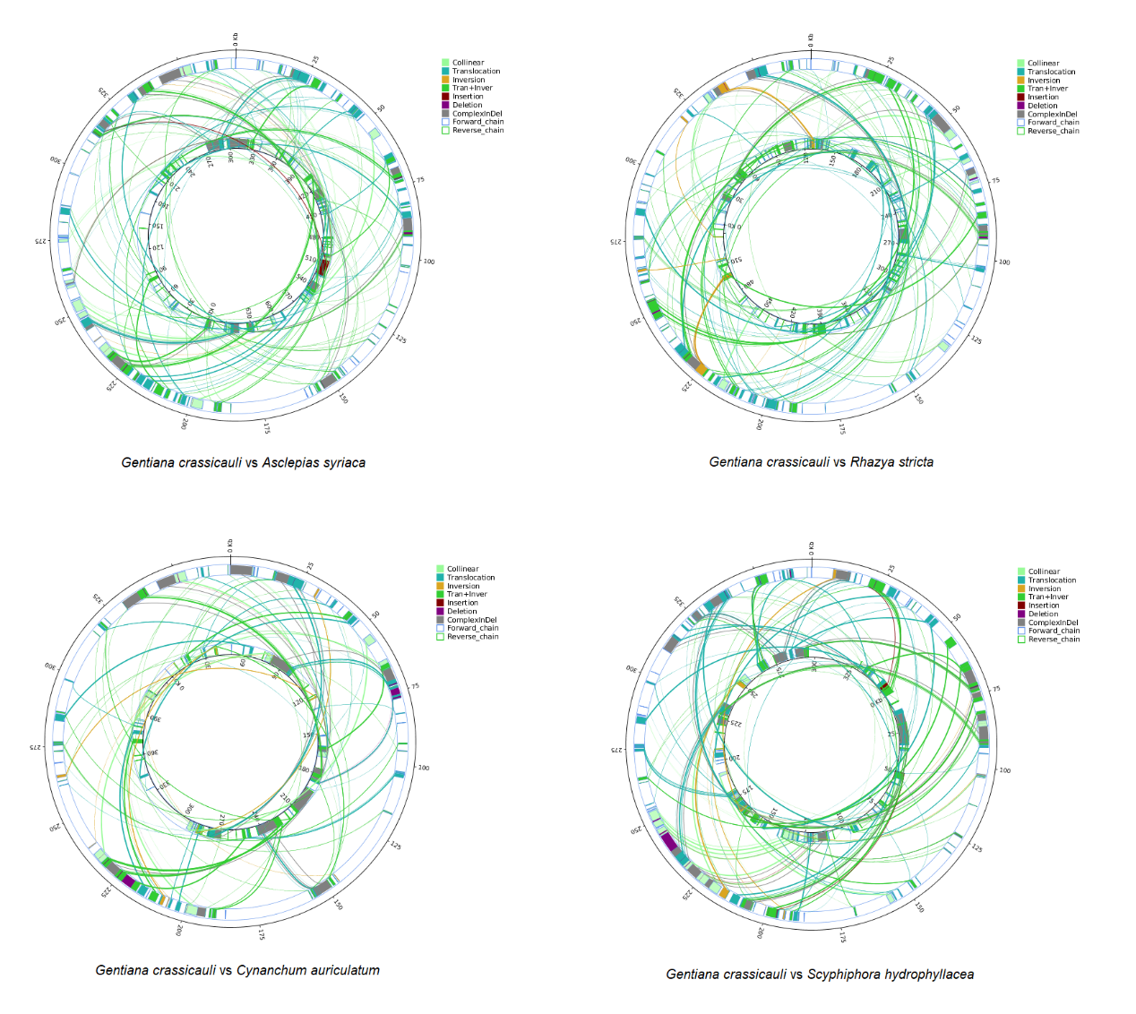
S2-1 Fig Structural variation map of mitochondrial genomes of G. crassicaulis and other four Gentianales plants, respectively.
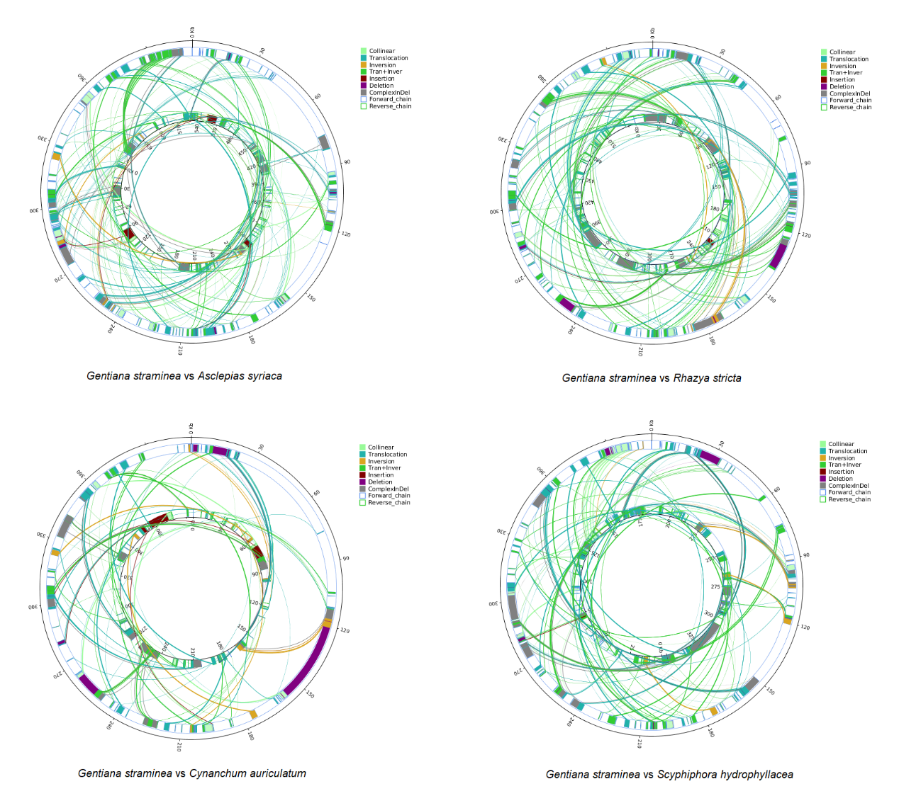
S2-2 Fig Structural variation map of mitochondrial genomes of G. straminea and other four Gentianales plants, respectively.

