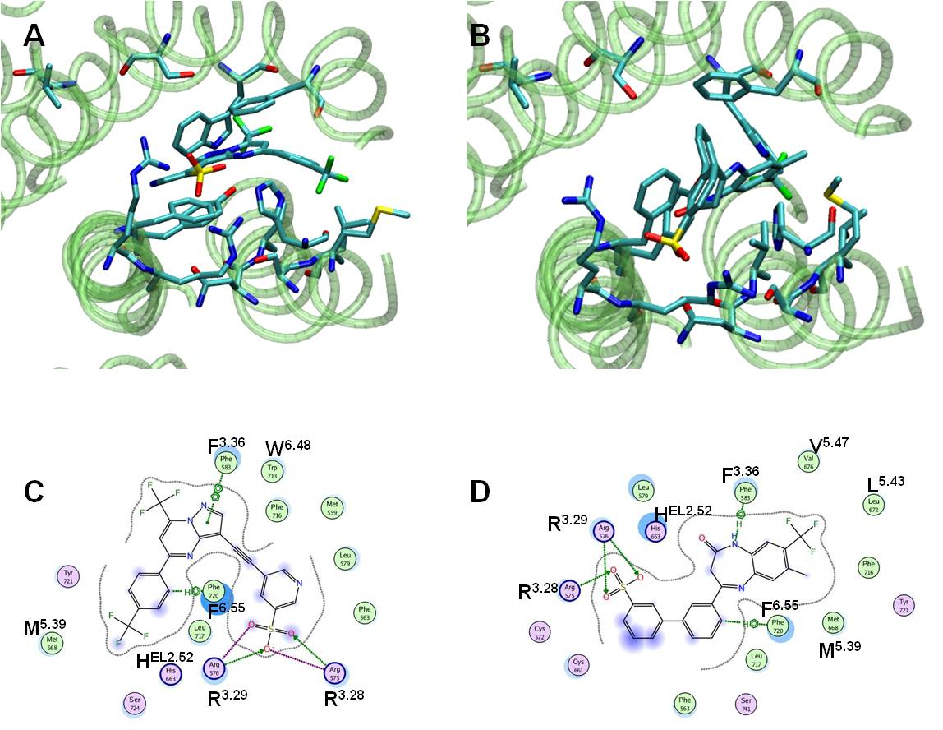
Figure S12. Analysis of the docking studies. Representation of the docking pose for the RO4988546 (A) and RO5488608 (B) compounds and the ligand-receptor interaction C and D respectively.

