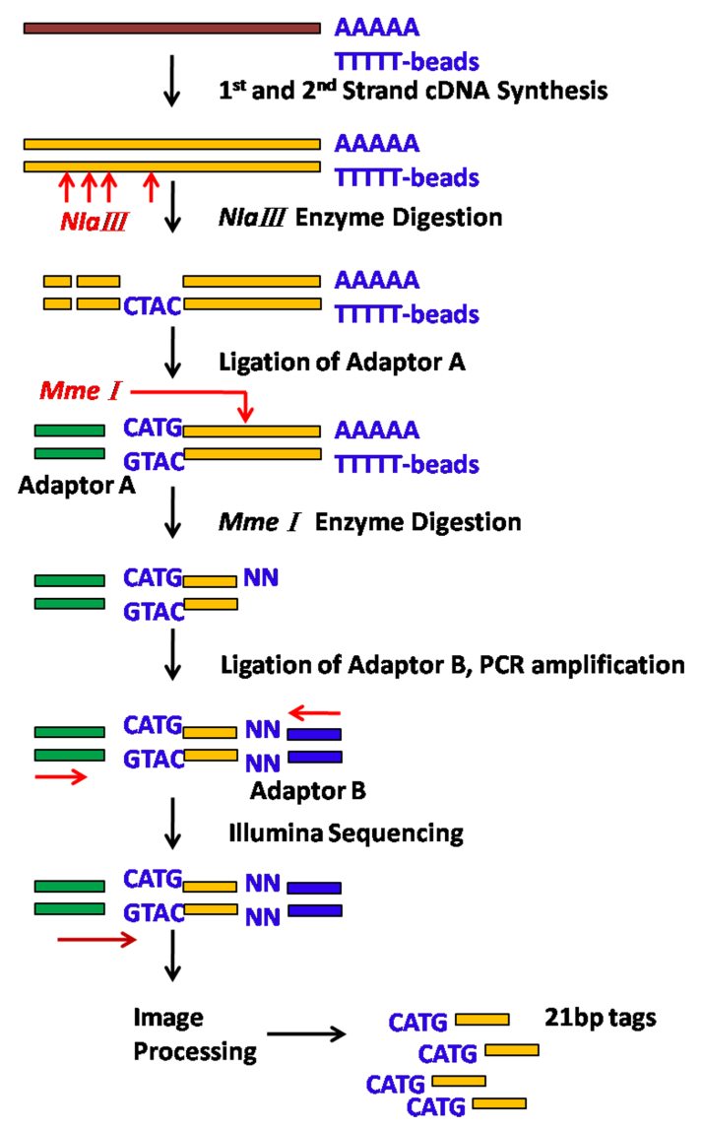
FigureS2. Principle and procedure of Tag preparation for DGE pipeline [1].
Beads of Oligo(dT) are used to enrich mRNA from the total RNA, and then are synthesized to the first and second-strand cDNA by use of Oligo(dT) as primer. Subsequently restriction enzyme NlaⅢ recognizes and cut off the CATG sites of cDNA strand, and the Illumina adaptor A is ligated to the sticky 5' end. In the same, MmeⅠ which is a type of Endonuclease cut at 17bp downstream of the CATG site, and the Illumina adaptor B is ligated to the 3’ ends of tags, consequently, a tag library that tags with different adaptors of both ends is acquired. After 15 cycles of linear PCR amplification, 95bp fragments are purified by 6% TBE PAGE Gel electrophoresis. The purified fragments were used directly for cluster generation and sequencing analysis using the Illumina Hiseq2000 following manufacturer protocols (BGI, China).

SUPPLEMENTAL REFERENCE

- Morrissy AS, Morin RD, Delaney A, Zeng T, McDonald H, et al. (2009) Next-generation tag sequencing for cancer gene expression profiling. Genome Research 19(10):1825-35.

