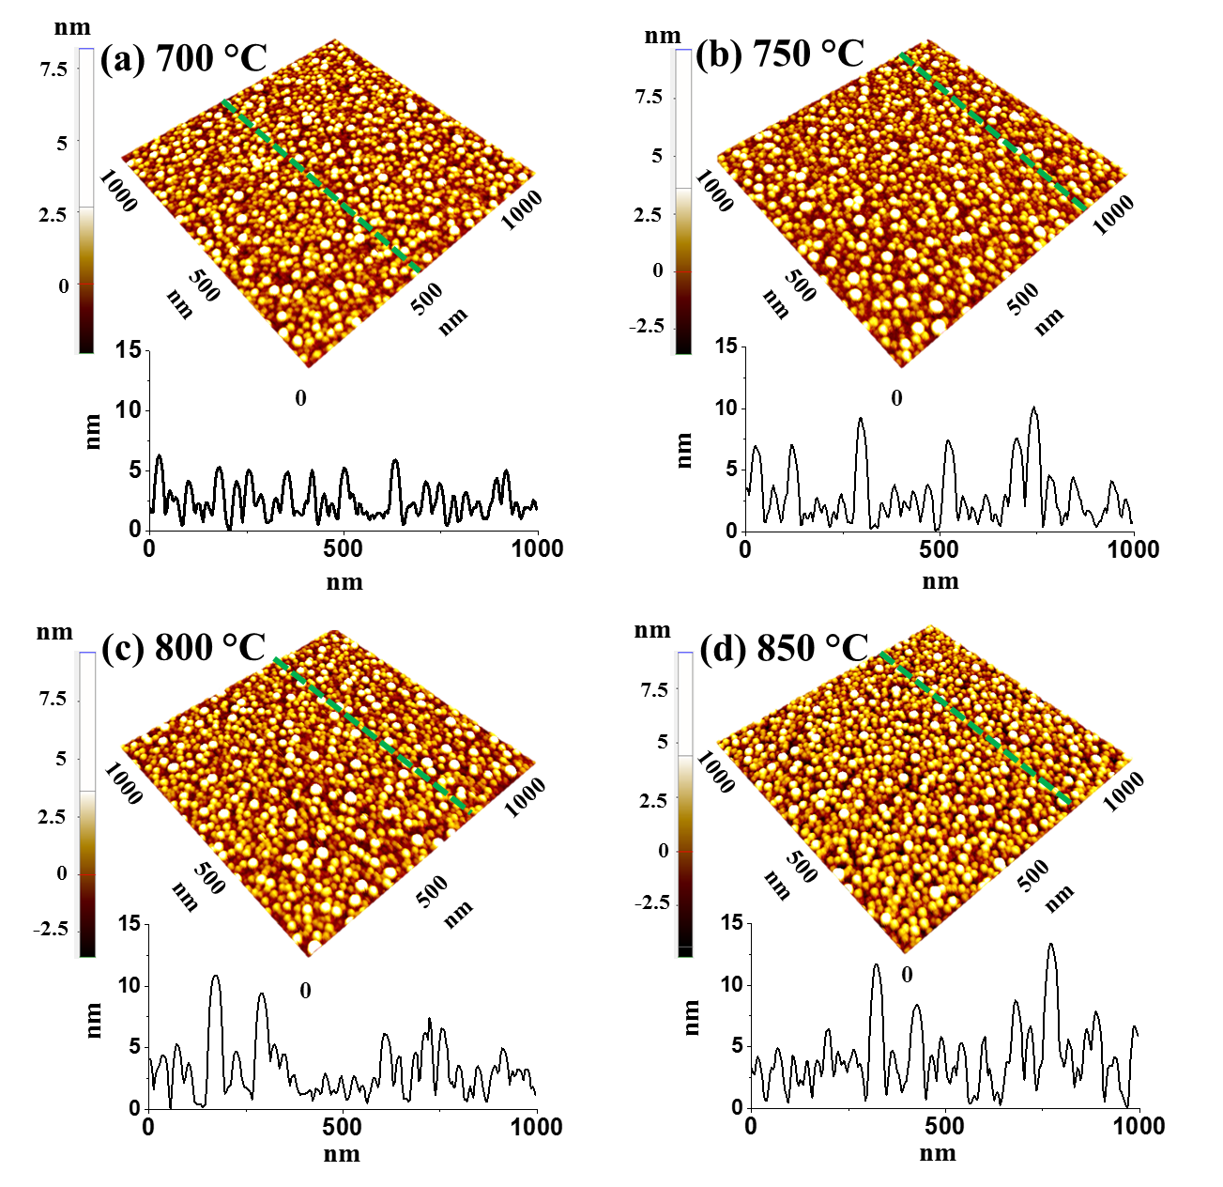
S9 Fig. Uniform Pt NPs on sapphire (0001) by the systematic control of annealing temperature from 700 to 850 °C for 450 s. The total bilayer thickness was of 6 nm with the In_{4.5 nm}/Pt_{1.5 nm} bilayer. (a) – (d) AFM side-views (1 × 1 µm²). (a-1) – (d-1) Cross-sectional line profiles.

