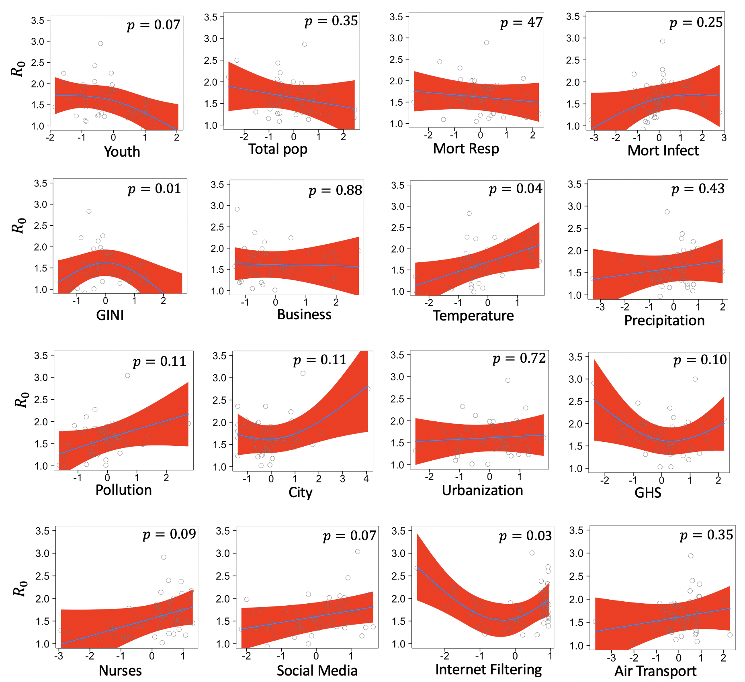
Fig. S5. Fixed GAM derived effects of covariates on R₀ across countries. Circles are partial residuals, and red shades are 95% confidence intervals.

