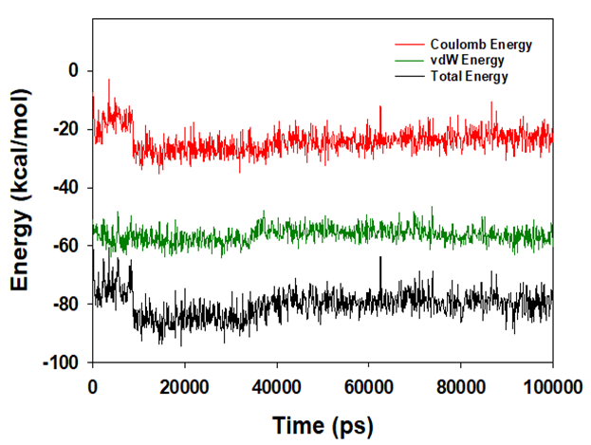
Figure S1: Energy plot of protein ligand complex system during the entire simulation event of 100 ns. The total energy (black), van der Waal’s energy (green) and coulomb energy (red) of the entire system indicating the stability of the individual systems.

