S1 Fig: Height-for-age Z-score by child age among a sample of 3,494 children
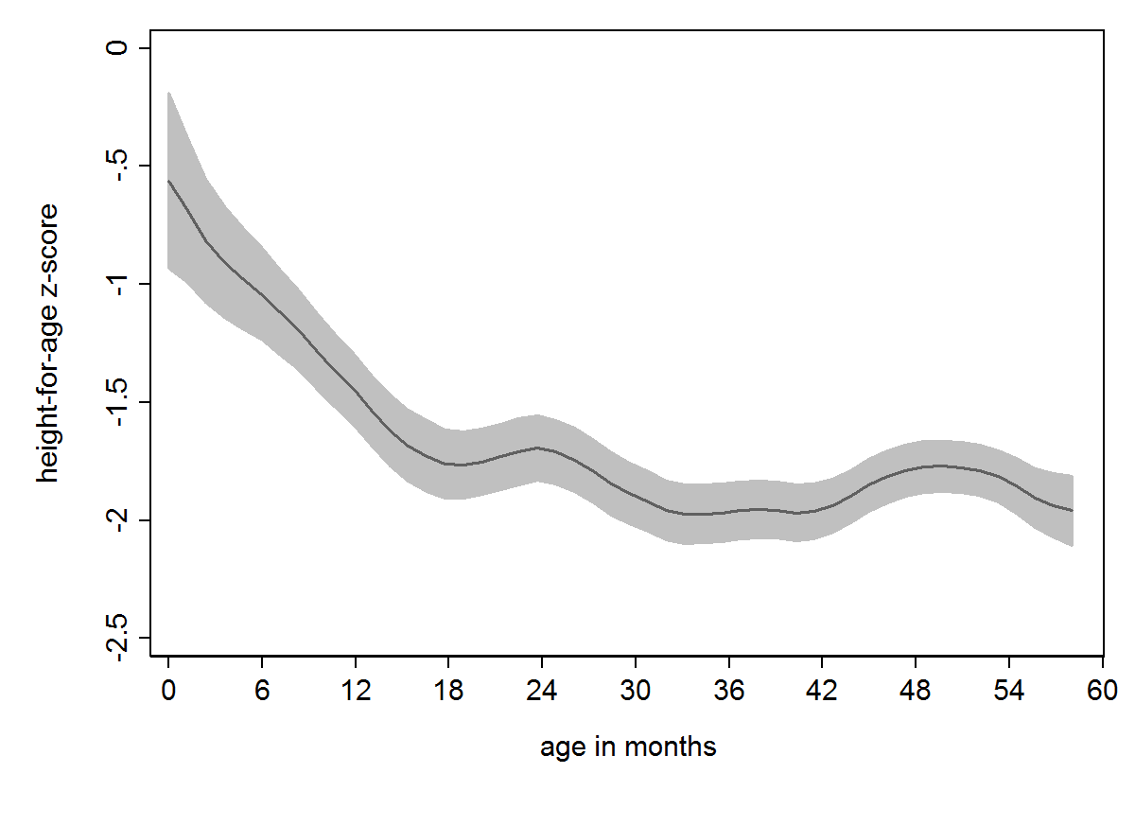
Notes: This predicted relationship is generated by a local polynomial kernel smoother
with 95% confidence intervals.

