Supplementary Material
S1 Appendix
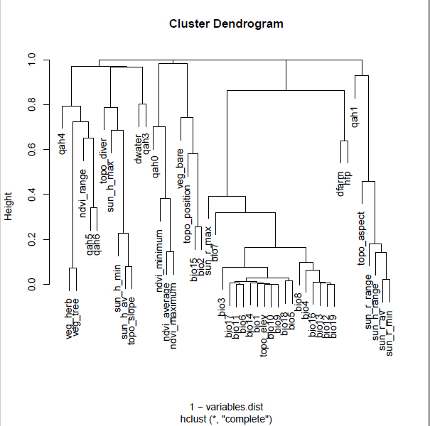
S1 Appendix. Cluster dendrogram or correlation matrix of the environmental variables included as predictors in the latent selection difference function (LSD) approach. For definitions of variables see section 2.3 (material and methods).

