S1 Table. Final 31-item Weight Literacy Scale – English

Survey # | Statement  Please read each statement and circle whether it is: True, False or Don’t Know.
1 | Drinking water instead of juice can help a person lose weight. | True* | False | Don’t know
2 | Certain moods can make people want to eat high-calorie foods. | True* | False | Don’t know
3 | Any physical activity burns calories. | True* | False | Don’t know
4 | Having friends that are physically active can help a person be more active. | True* | False | Don’t know
5 | In equal amounts, fried foods have fewer calories than grilled foods. | True | False* | Don’t know
6 | Alcoholic beverages have few calories. | True | False* | Don’t know
7 | Regular meats have fewer calories than lean meats. | True | False* | Don’t know
8 | The only way to lose weight is eating healthy foods. | True | False* | Don’t know
9 | Tracking what we eat can help us understand how to cut calories. | True* | False | Don’t know
10 | To keep their weight stable, some people need to eat more calories than other people. | True* | False | Don’t know
11 | Some salad dressings and vinaigrettes can add many calories to a salad. | True* | False | Don’t know
12 | In equal amounts, mustard has fewer calories than mayonnaise. | True* | False | Don’t know
13 | A lunch that has 1,500 calories is healthy for most adults. | True | False* | Don’t know
14 | An overweight adult who does not exercise needs to eat about 500 fewer calories a day to lose one pound per week. | True* | False | Don’t know
15 | A weight loss goal of 1-2 pounds per week is commonly recommended. | True* | False | Don’t know
16 | A healthy snack should contain at least 300 calories. | True | False* | Don’t know
17 | 100% fruit juice contains very few calories. | True | False* | Don’t know
18 | A calorie tells us how healthy a food is. | True | False* | Don’t know
19 | Regular energy drinks contain few calories. | True | False* | Don’t know
20 | People tend to overeat when there is a lot of food around them. | True* | False | Don’t know
21 | Setting goals for changing diet and physical activity can help people lose weight. | True* | False | Don’t know
22 | Eating fried foods less often can help a person lose weight. | True* | False | Don’t know
23 | Eating smaller portions can help people lose weight. | True* | False | Don’t know

For the following four multiple-choice questions, please circle one answer.
24 | How many calories a day should an active man eat to have a healthy weight? (An example of an active man is someone who walks briskly for 30 minutes on most days of the week)  - Less than 1,000 calories  - 1,500 to 2,500 calories*  - 3,000 to 4,000 calories  - 4,500 calories or more  - Don’t know
25 | How many calories a day should an active woman eat to have a healthy weight? (An example of an active woman is someone who walks briskly for 30 minutes on most days of the week)  - Less than 1,000 calories  - 1,500 to 2,500 calories*  - 3,000 to 4,000 calories  - 4,500 calories or more  - Don’t know

Please read each nutrition label before answering the questions.

This nutrition label is from a pizza box:
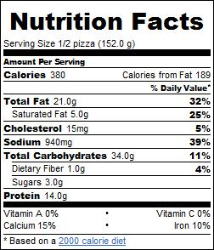

Based on this pizza label, please circle whether the following three statements are: True, False, or Don’t Know.

26a | One serving has 380 calories. | True* | False | Don’t know
26b | The entire pizza has 3 servings. | True | False* | Don’t know
26c | If you ate the whole pizza, you would be eating 760 calories. | True* | False | Don’t know
This nutrition label is from a soda container:
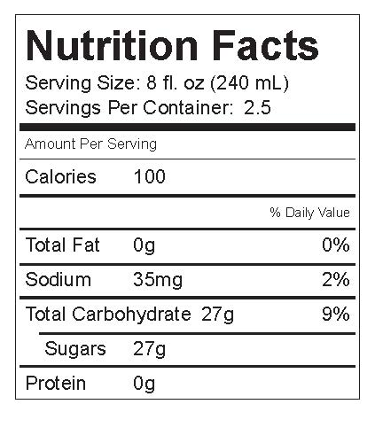

Based on this soda container label, please circle the following three statements are: True, False, or Don’t Know.

27a | One serving has 150 calories. | True | False* | Don’t know
27b | The entire soda can has 2 servings. | True | False* | Don’t know
27c | If you drank the entire soda bottle, you would be drinking 300 calories. | True | False* | Don’t know

