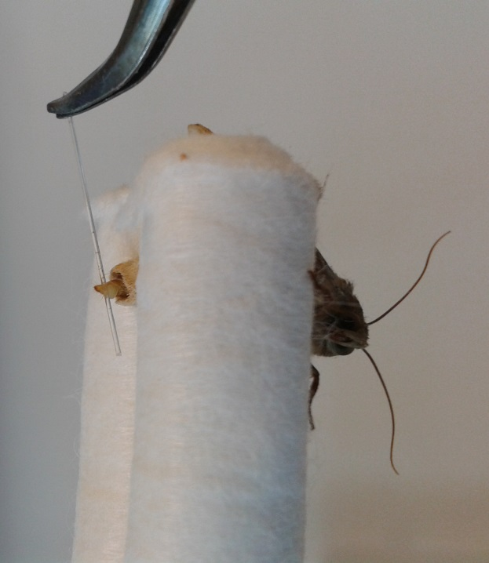
Fig S3. Handing of moth and disposable PDMS fiber during pheromone sampling.

