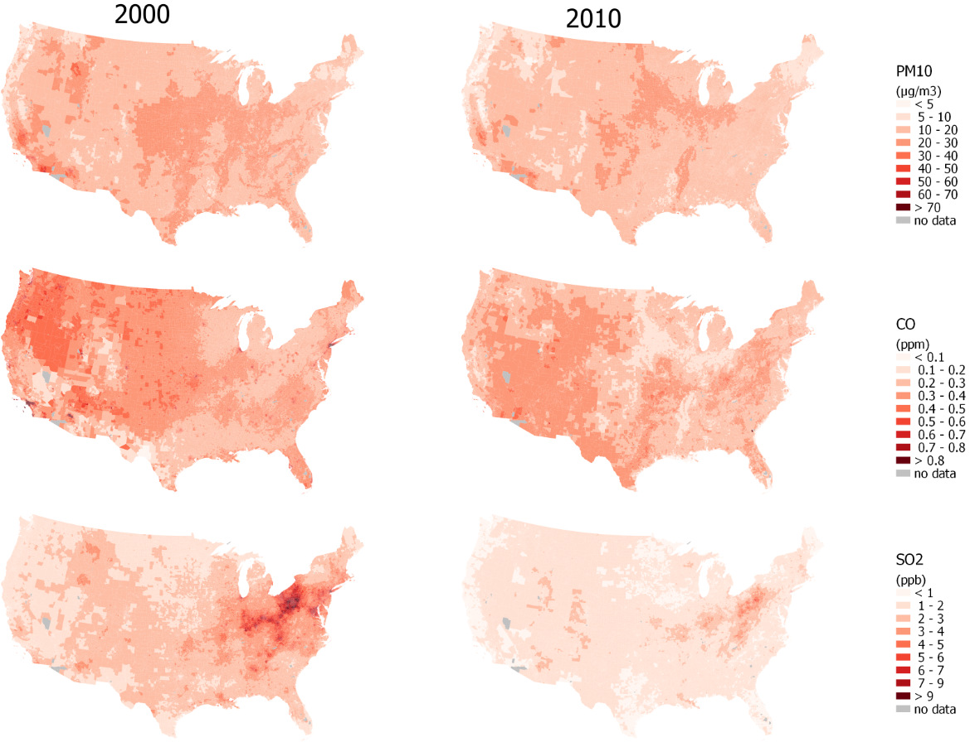
Figure S14. Maps of Census Block Group population-weighted mean for PM₁₀, CO, and SO₂ from the “best” Integrated Empirical Geographic (IEG) models mostly including 3-30 geographic variables for 2000 and 2010 in the contiguous U.S.

