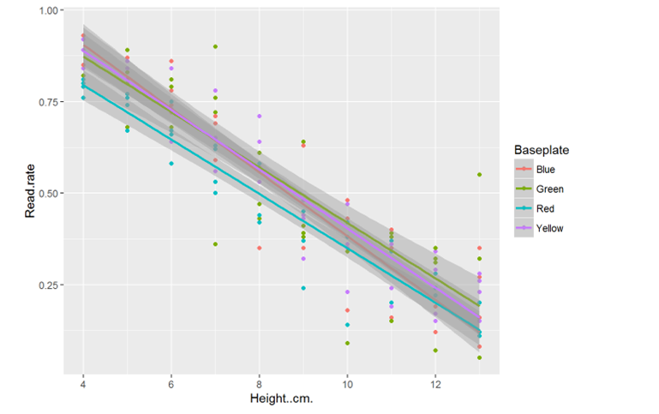

Figure S2: Relationship between RFID transponder read rate and height above baseplate from the ex vivo experiment
The regression analysis assumes a linear relationship between height and read rate. A linear relationship was obtained for all 4 baseplates (designated ‘blue’, ‘green’, ‘red’ and ‘yellow’). The gray region is the 95% confidence interval for the fitted line.

