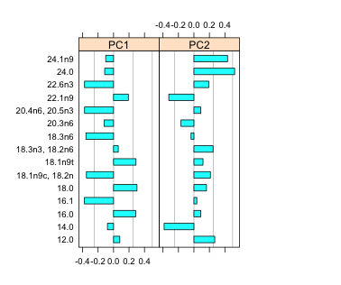
Figure S2. Loadings for Principal Component Analysis (PCA) of fatty acids for Thalassiosira pseudonana and Acartia tonsa.

FAs 22.6n3, 20.4n6.20.5n3, 18.3n6, 18.3n3-18.2n6, and 16.1 contributed most to Axis 1, and 24.0 and 14.0 to Axis 2. PCA is shown in Figure 2b.

