Nanosize fraction (2-10µm)
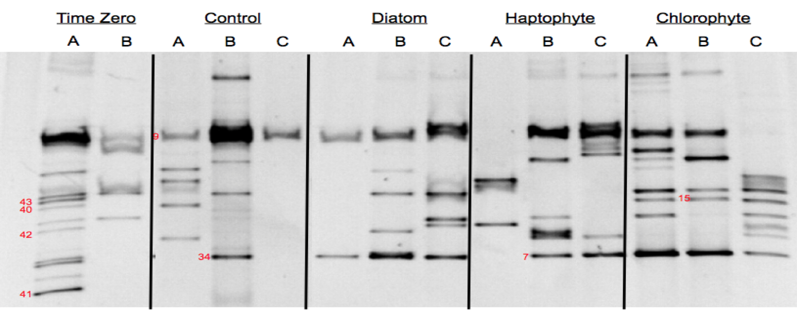

Microsize fraction (10-80µm)
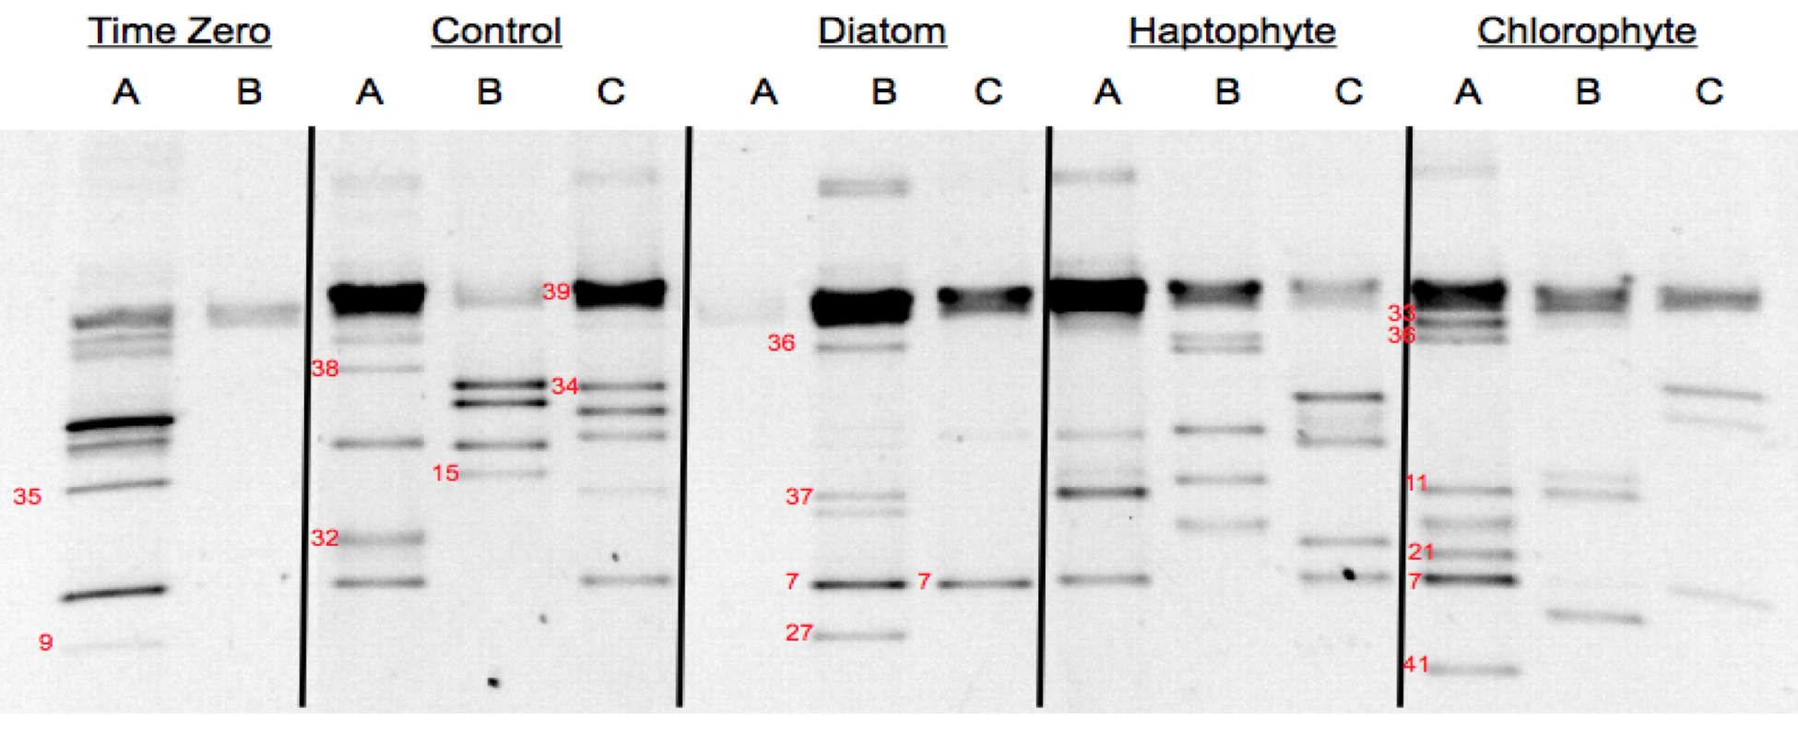
S6 Fig. DGGE of bottom up experiment 3 (BU 3) using Spirotrichea primers shows high variability among replicates. Each lane presents a replicate of Time Zero, control, and three bloom treatments. Other notes as in Figure S4.

