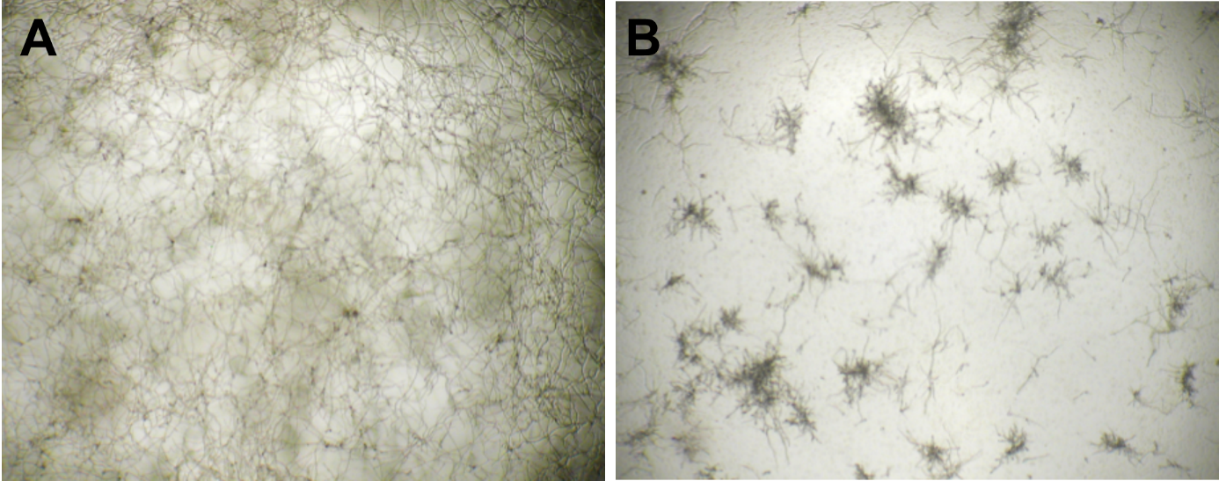

S3 Fig. Anti-mycologic activity of ML6. Hyphae of a plant pathogenic fungus, Mycosphaerella zeae, grow profusely in (A) untreated media, but are (B) stunted following 24 hour treatment with ML6 (500nM). Hyphae remained stunted for 19 days in the presence of ML6, after which the experiment was ended.

