Supplementary Figure S2: Expression of osteogenic markers in MSC during differentiation.

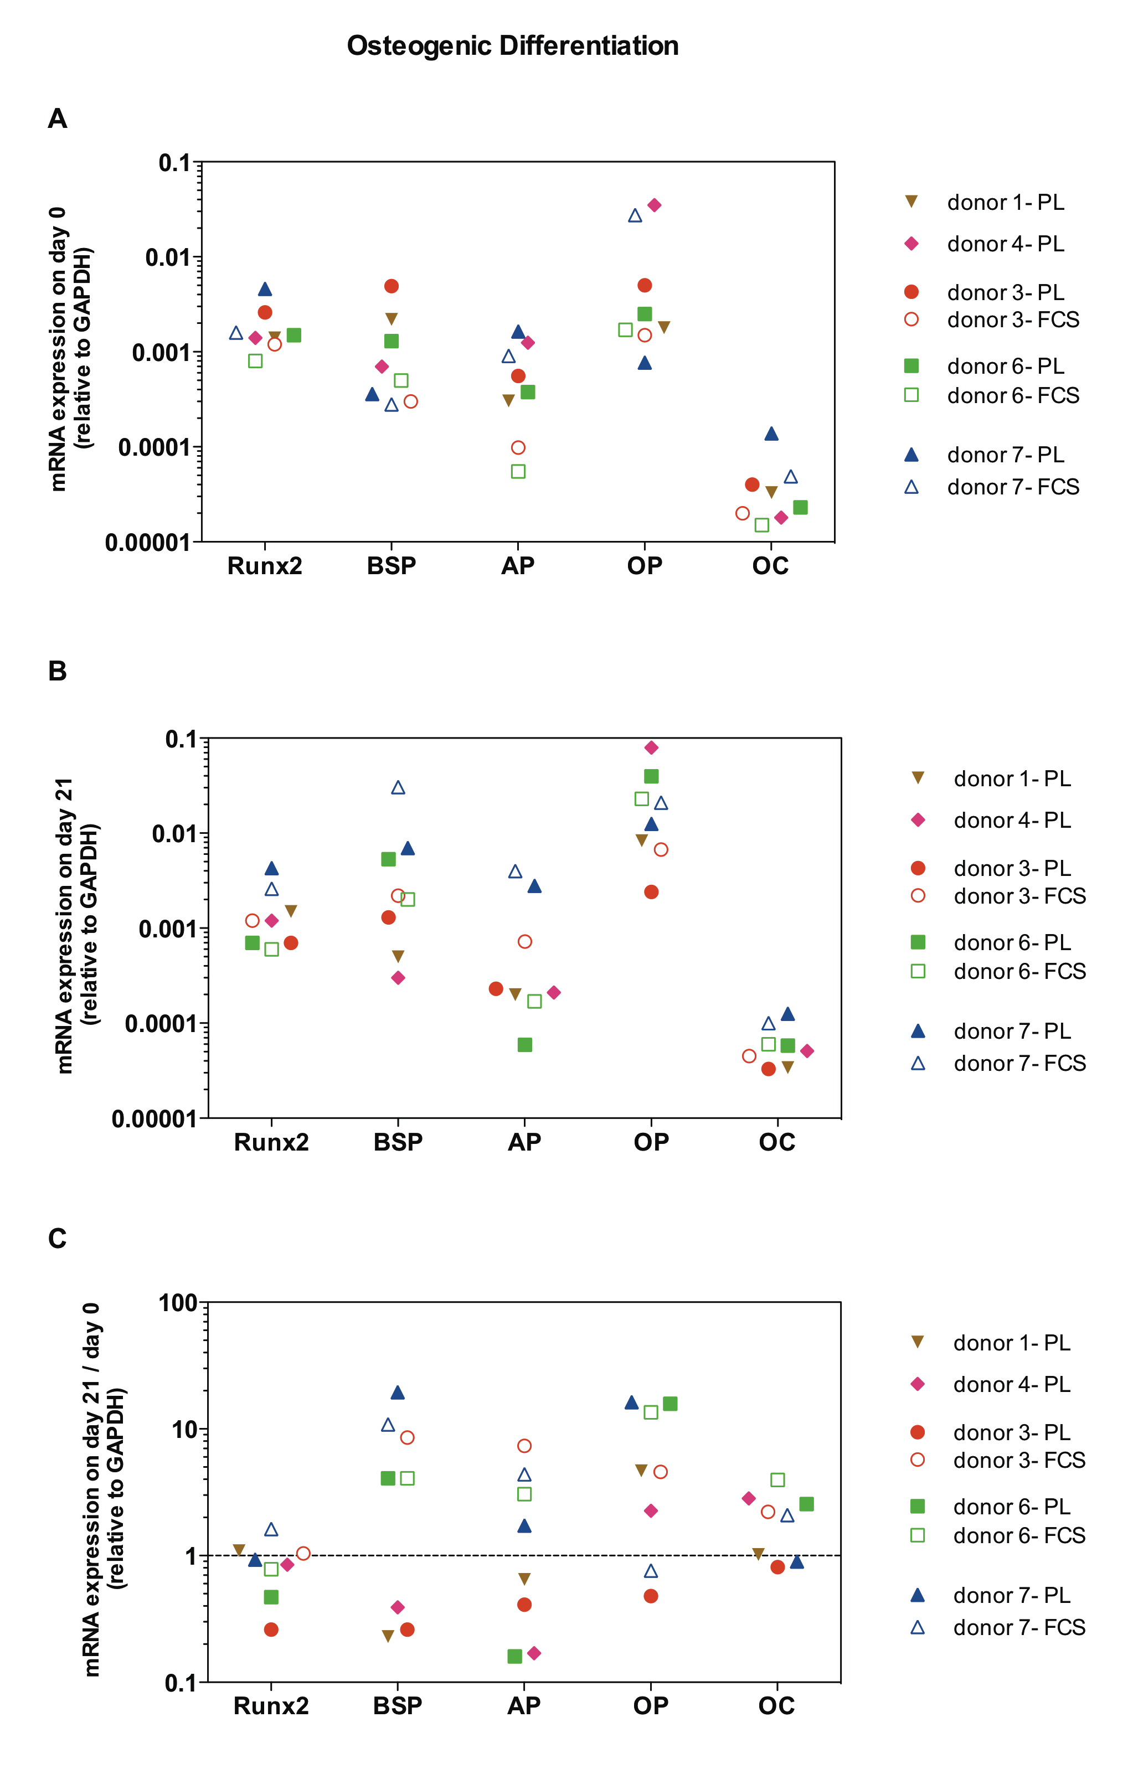

mRNA expression of the transcription factor Runx2 and osteogenic markers: bone sialo protein (BSP), alkaline phosphatase (AP), osteopontin (OP) and osteocalcin (OC) in MSC cultured in osteogenic conditions was quantitatively measured and normalised to house-keeping gene GAPDH levels. MSC were isolated in complete medium CMSSP supplemented with 10% platelet lysate (PL) or with 10% fetal calf serum (FCS). A) relative mRNA expression on day 0. B) relative mRNA expression on day 21, C) relative mRNA expression on day 21 versus day 0. Dotted line indicates mRNA at day 0.

