KUWAIT

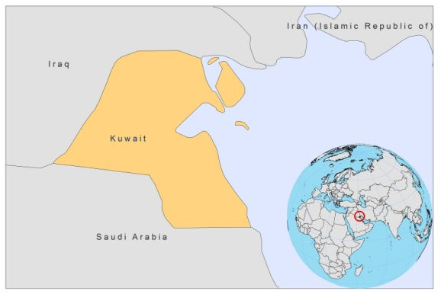

BASIC COUNTRY DATA

Total Population: 2,736,732
Population 0-14 years: 27%
Rural population: 2%
Population living under USD 1.25 a day: no data
Population living under the national poverty line: no data
Income status: High Income economy
Ranking: High human development (ranking 63)
Per capita total expenditure on health at average exchange rate (US dollar): 1,416
Life expectancy at birth (years): 74
Healthy life expectancy at birth (years): 67

BACKGROUND

More than one million immigrants work in Kuwait and the majority come from VL endemic countries such as India, Bangladesh and Nepal; and CL endemic countries such as Syrian Arab Republic, Iran (Islamic Republic of) and Afghanistan. VL and CL are reported in Kuwait, but mainly as an imported disease. VL is not endemic in Kuwait and imported cases occur sporadically in migrant workers [1]. As the vector is present, there is a theoretical risk of VL spreading within Kuwait [2]. CL may be endemic, although no infected reservoir was found in an extensive study [3]. There were no proven autochtonous cases until 1983 [3], but in 1991, CL was claimed to be endemic [4]. Hundreds of cases have been admitted and treated in hospitals in Kuwait [5], but most are thought to be imported. CL is also occasionally reported in returning military personnel. Two returning US soldiers were thought to have contracted CL in Kuwait, near the Iraqi border [6].

PARASITOLOGICAL INFORMATION
Leishmania species | Clinical form | Vector species | Reservoirs
L major | ZCL | Unknown | Unknown

NO FURTHER INFORMATION IS AVAILABLE

SOURCES OF INFORMATION

1. Iqbal J, Hira PR, Saroj G, Philip R, Al-Ali F, et al (2002). Imported Visceral Leishmaniasis: Diagnostic Dilemmas and Comparative Analysis of Three Assays. J Clin Microbiol 40 (2): 475–479.

2. Cope SE, Schultz GW, Richards AL, Savage HM, Smith GC et al (1996). Assessment of arthropod vectors of infectious diseases in areas of U.S. troop deployment in the Persian Gulf. Am J Trop Med Hyg 54:49–53.

3. Hussein MS (1983). The epidemiology of cutaneous leishmaniasis in Kuwait. Ann Trop Med Parasitol 77(1):27-33.

4. al-Fouzan AS, al Saleh QA, Najem NM, Rostom A (1991). Cutaneous leishmaniasis in Kuwait. Clinical experience with itraconazole. Int J Dermatol 30(7):519-21.

5. Al-Mutairi N, Alshiltawy M, El Khalawany M, Joshi A, Eassa BI, et al (2009). Tropical medicine rounds: Treatment of Old World cutaneous leishmaniasis with dapsone, itraconazole, cryotherapy, and imiquimod, alone and in combination. Int J Dermatol 48(8):862-9.

6. Cutaneous leishmaniasis in U.S. military personnel--Southwest/Central Asia, 2002-2003. Centers for Disease Control and Prevention (CDC). MMWR Morb Mortal Wkly Rep. 2003; 24;52(42):1009-12.

