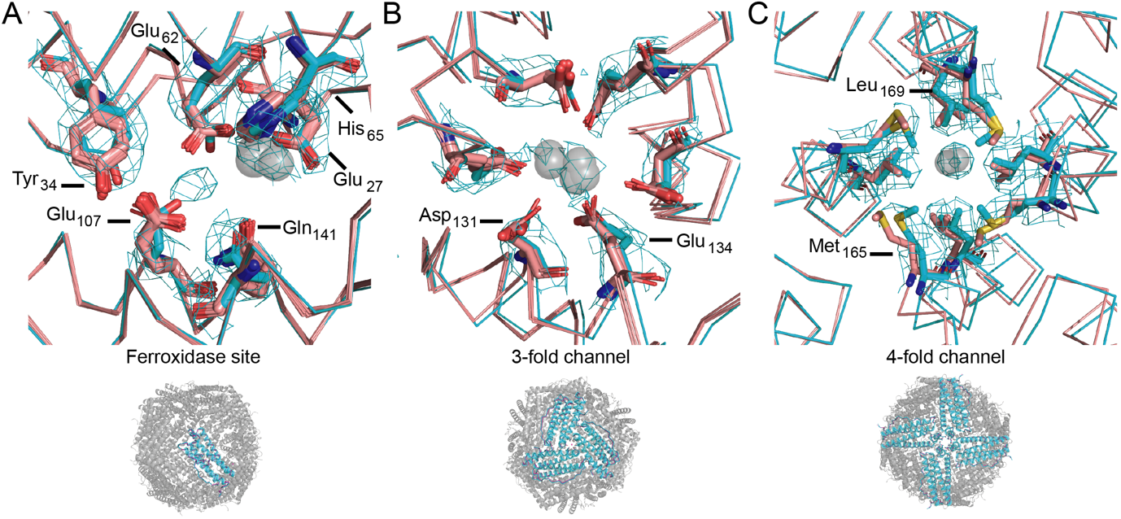
S8 Fig. Apoferritin metal ion (grey transparent spheres) binding sites in our cryo-EM reconstruction (cyan) overlaid with the crystal structure (pink). (A) ferroxidase site (Mg²⁺), (B) three-fold axis channel (Mg²⁺) and (C) four-fold axis channel (Fe²⁺/Fe³⁺).

