The ARRIVE Guidelines Checklist
Animal Research: Reporting In Vivo Experiments
Carol Kilkenny¹, William J Browne², Innes C Cuthill³, Michael Emerson⁴ and Douglas G Altman⁵
¹The National Centre for the Replacement, Refinement and Reduction of Animals in Research, London, UK, ²School of Veterinary Science, University of Bristol, Bristol, UK, ³School of Biological Sciences, University of Bristol, Bristol, UK, ⁴National Heart and Lung Institute, Imperial College London, UK, ⁵Centre for Statistics in Medicine, University of Oxford, Oxford, UK.

 |  | ITEM | RECOMMENDATION | Section/  Paragraph
 |  |  |  | Title page
 |  |  |  | Abstract
 | INTRODUCTION
 | 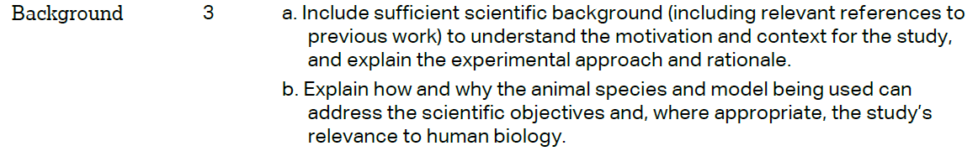 |  |  | Introduction  Introduction
 |  |  |  | Introduction
 | METHODS
 |  |  |  | Materials and Methods
 | 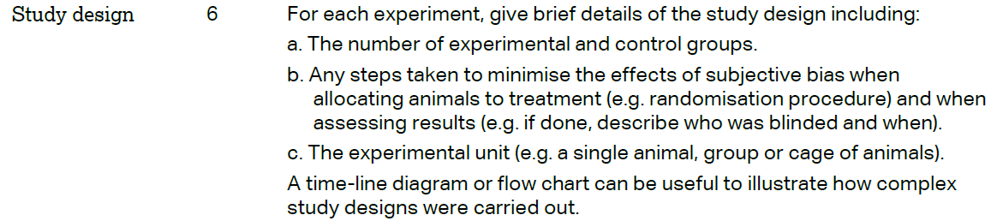 |  |  | Materials & Methods  Materials & Methods  Materials & Methods
 | 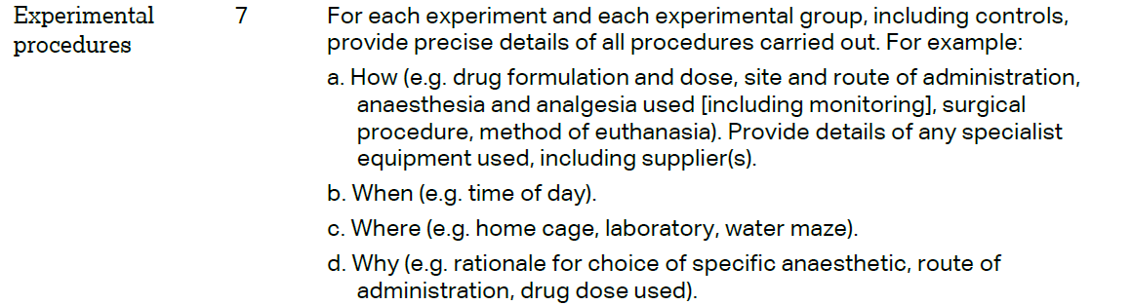 |  |  | Materials & Methods  Materials & Methods  Materials & Methods  Materials & Methods
 | 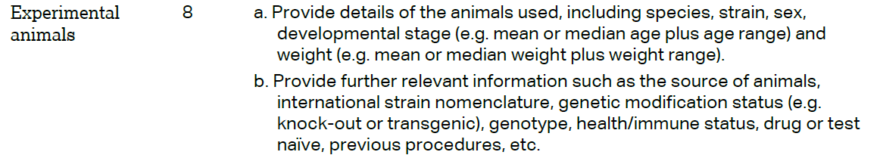 |  |  | Materials & Methods  Materials & Methods
The ARRIVE guidelines. Originally published in PLoS Biology, June 2010¹
 | 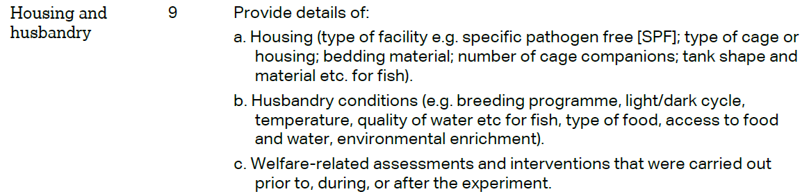 | Materials & Methods  Materials & Methods  Materials & Methods
 | 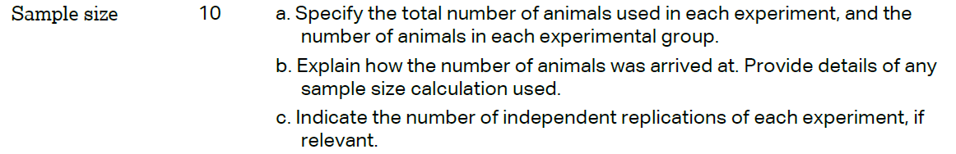 | Materials & Methods  Results  Results
 | 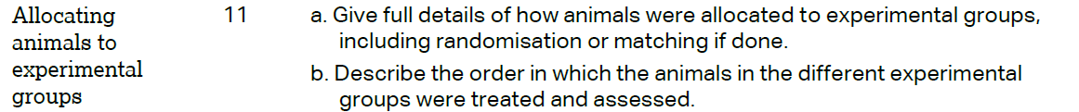 | Methods & Materials  Methods & Materials
 |  | Materials & Methods
 | 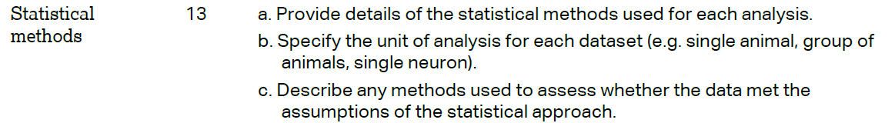 | Materials & Methods  Results  Materials & Methods
 | RESULTS
 |  | Materials & Methods
 |  | Results
 |  | Results
 |  | Results
 | DISCUSSION
 | 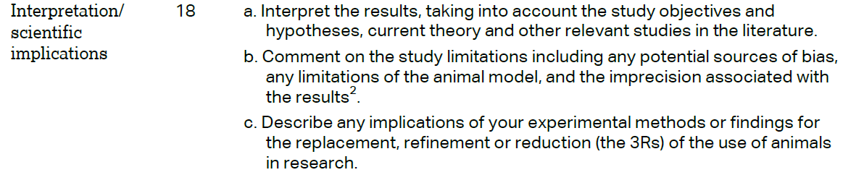 | Discussion  Discussion  N/A
 |  | Discussion
 |  | Acknowledgements
