Supporting Information
Drug repositioning for cancer therapy using a chemical genomics approach based on large-scale drug-induced transcriptional signatures
Haeseung Lee, Seungmin Kang, and Wankyu Kim*

Ewha Research Center for Systems Biology, Division of Molecular & Life Sciences, Ewha Womans University, Seoul, Korea
* To whom correspondence should be addressed. Tel: +82-2-3277-4132; Fax: +82-2-3277-6809; Email: wkim@ewha.ac.kr

Figure A. The compound set used in this work.
Figure B. The public HTS datasets are reasonably distinct.
Figure C. Performance evaluation using the public anti-cancer HTS dataset as a benchmark in total compound space.

Table A. List of PubChem HTS datasets for glioblastoma, lung cancer, and breast cancer.
Table B. The five clusters of similar pathway enrichment patterns with the active DR candidates and 15 other cancer drugs.

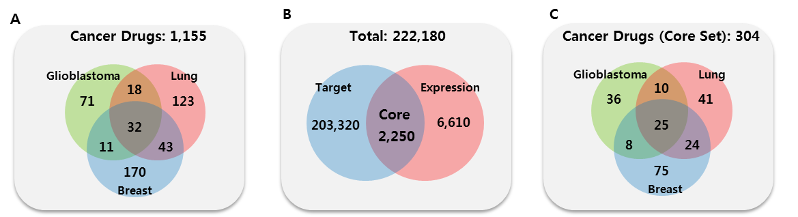
Figure A. The compound set used in this work. (A) The cancer drug set (CD set) and known drug set (KD set) for glioblastoma, lung cancer, and breast cancer. (B) The compound set with one or more known targets (T) and expression signature (E). Structural signatures (S) are available for all compounds. The core set consisted of 2,250 compounds with all three types of signatures (S, T, and E). (C) The CD set and KD set that are included in the core set.

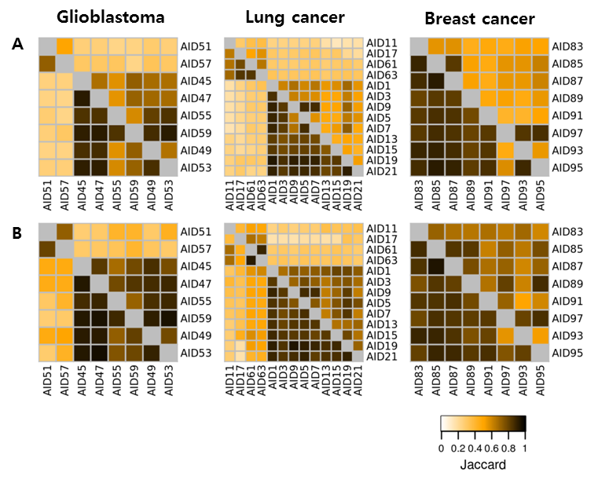
Figure B. The public HTS datasets are reasonably distinct. The redundancy among the public HTS datasets measured using the Jaccard index for (A) the hit compounds (upper diagonal) and total assayed compounds. (B) The same as (A) except that only the compounds in the core set were counted.
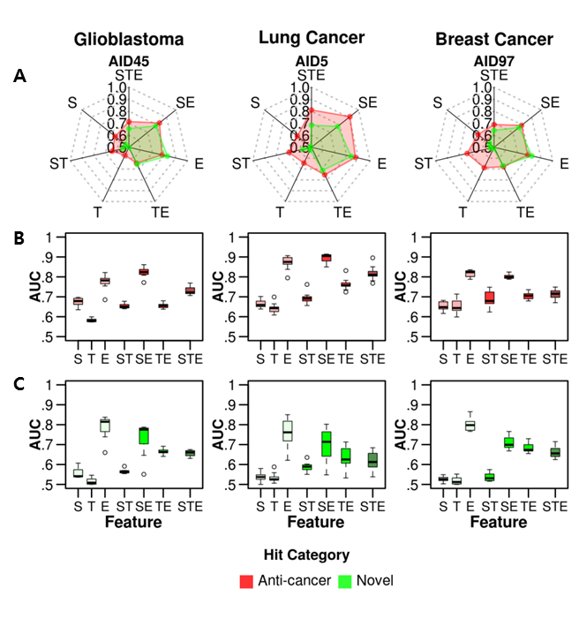
Figure C. Performance evaluation using the public anti-cancer HTS dataset as a benchmark in total compound space. The seven classifiers (S, T, E, ST, SE, TE, and STE) were evaluated based on the AUCs of the ROC curve for glioblastoma, lung cancer, and breast cancer. All assayed compounds were evaluated. The AUC values were calculated by averaging 100 rounds of 3-fold cross validation. (A) Typical examples of performance evaluation using the HTS data set for glioblastoma (AID45), lung (AID5), and breast cancer (AID97). The AUCs were independently calculated using two distinct sets of hit compounds as a benchmark (or positives)—i.e., i) the hit compounds of known anti-cancer activity (red lines) and ii) novel hits (green lines). The distribution of AUCs using (B) the compounds of known anti-cancer activity as a benchmark, and (C) novel hits as a benchmark
Table A. List of PubChem HTS datasets for glioblastoma, lung cancer, and breast cancer.
AID | Hit  compound | Test  compound | Hit  (Core) | Test  (Core) | Cell line | Cell type
AID45 | 2,054 | 40,818 | 33 | 219 | SF-268 | Glioblastoma
AID47 | 2,075 | 41,186 | 37 | 219 | SF-295
AID49 | 2,119 | 38,553 | 37 | 214 | SF-539
AID51 | 786 | 11,942 | 24 | 78 | XF 498
AID53 | 1,730 | 40,717 | 33 | 220 | SNB-19
AID55 | 2,101 | 38,474 | 40 | 215 | SNB-75
AID57 | 591 | 13,466 | 18 | 78 | SNB-78
AID59 | 2,219 | 41,196 | 41 | 220 | U251
AID1 | 2,098 | 41,244 | 40 | 202 | NCI-H23 | Non-small cell lung cancer
AID3 | 1,857 | 37,995 | 32 | 193 | NCI_H226
AID5 | 1,581 | 39,900 | 33 | 204 | NCI-H322M
AID7 | 2,422 | 39,900 | 40 | 201 | NCI-H460
AID9 | 1,913 | 39,961 | 40 | 202 | HOP-62
AID11 | 608 | 11,078 | 19 | 72 | HOP-18
AID13 | 1,987 | 36,402 | 39 | 200 | HOP-92
AID15 | 2,768 | 37,442 | 42 | 199 | NCI-H522
AID17 | 730 | 13,394 | 21 | 53 | LXFL 529
AID19 | 2,023 | 41,473 | 36 | 207 | A549/ATCC
AID21 | 1,482 | 40,250 | 31 | 202 | EKVX
AID61 | 909 | 13,208 | 26 | 78 | DMS 273 | Small cell lung cancer
AID63 | 948 | 14,286 | 26 | 81 | DMS 114
AID83 | 2,361 | 28,597 | 40 | 189 | MCF7 | Breast cancer cell line
AID85 | 1,867 | 28,261 | 30 | 179 | MDA-MB-435
AID87 | 1,820 | 27,662 | 30 | 178 | MDA-N
AID89 | 1,280 | 25,315 | 28 | 159 | BT0549
AID91 | 1,556 | 26,679 | 31 | 173 | T-47D
AID93 | 1,472 | 28,546 | 30 | 187 | NCI/ADR-RES
AID95 | 1,454 | 27,770 | 27 | 175 | MDA_MB_231
AID97 | 1,464 | 26,619 | 31 | 170 | HS 578T

Table B. The five clusters of similar pathway enrichment patterns with the active DR candidates and 15 other cancer drugs.
DR candidates  (cluster) | Enriched Pathways |  | Cancer Drugs  In the same cluster | Target cancer type | Mode of Action
Maprotiline,  Nortriptyline  (I) | Up | Steroid synthesis  Immune system  Ribosome | Crizotinib | non-small cell lung carcinoma | ALK and ROS1 inhibitor
 |  |  | Fulvestrant | breast | estrogen receptor inhibitor
 |  |  | Vorinostat | lymphoma | histone deacetylases inhibitor
 | Down | Cell cycle, DNA repair  Energy metabolism  P53 signaling pathway  Ribosome | Tamoxifen | breast | estrogen receptor inhibitor
 |  |  | Saracatinib | broad cancers | c-Src/Abl kinase inhibitor
 |  |  | Toremifene | breast | estrogen receptor inhibitor
 |  |  | Sunitinib | kidney and gastrointestinal tract | receptor tyrosine kinase inhibitor
Astemizole  Amlodipine  (II) | Up | Steroid synthesis | Cediranib | Liver, lung, colon cancer  (+ other solid tumors) | VEGFR inhibitor
 | Down | Cell cycle, DNA repair
Mometasone  (III) | Up | -- | Trametinib | melanoma | MEK inhibitor
 | Down | Cell cycle, DNA repair | Exemestane | breast | aromatase inhibitors
Ivermectin  (IV) | Up | Aminoacid metabolism  Aminoacyl-tRNA syntesis | Dabrafenib | melanoma | BRAF and CRAF inhibitor
 |  |  | Azacitidine | broad cancers | DNA methyltransferase inhibitor
 | Down | Cell cycle, DNA repair  Steroid synthesis  P53 signaling pathway | Sorafenib | kidney | Raf kinase inhibitor
 |  |  | Vemurafenib | melanoma | BRAF inhibitor
Trifluridine  (V) | Up | P53 pathway | Axitinib | kidney, breast and pancreas | VEGFR inhibitor
 | Down | Cell cycle

