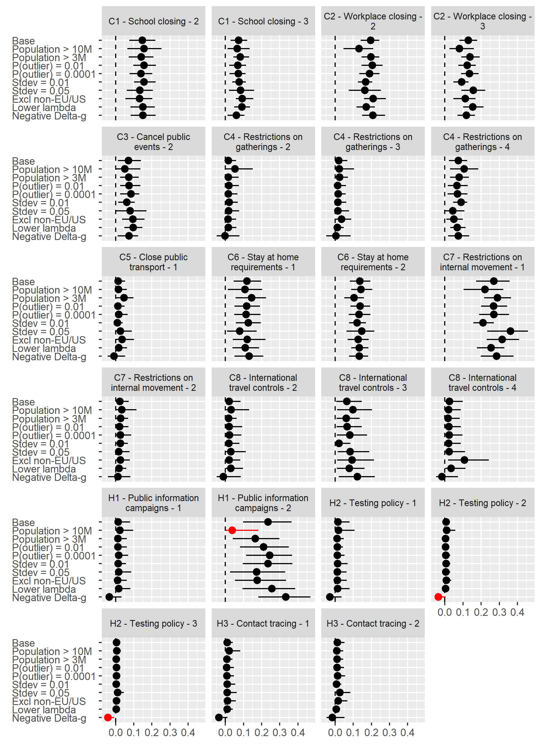
Figure S2. Sensitivity of policy effect estimates (as reported in Figure 2 of the main text) to different model specifications. Dots = median estimates; Lines = 95% intervals; Red = Base estimate outside of 95% posterior interval of changed specification.

