Supporting information

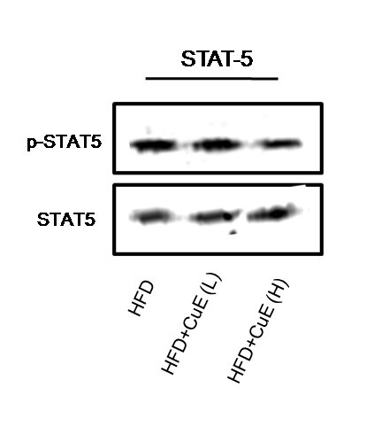

S3 Fig. Determination of the effect of CuE on STAT-5 activation in muscle tissue. (A) Total protein from muscle tissue of all mice groups was separated on 7.5% SDS-PAGE gels, and immunoblotted with phospho STAT5. The same blots were stripped and reprobed with a respective STAT protein antibody.

