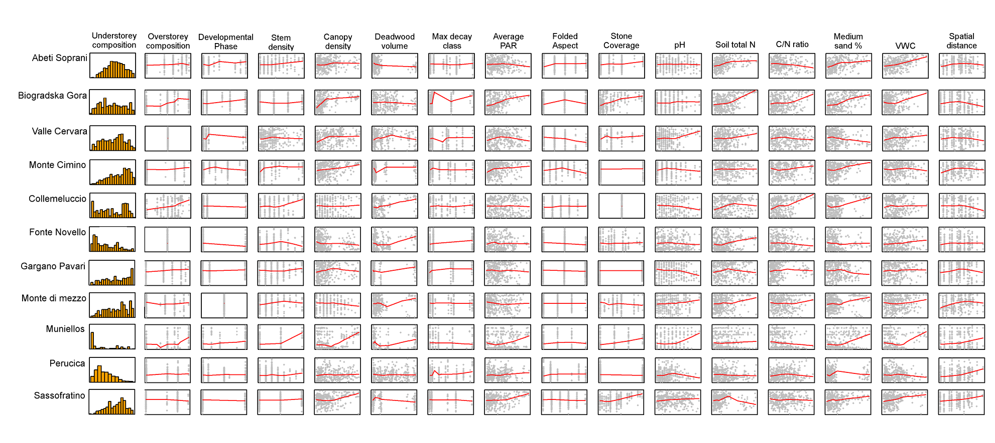
Figure S5 – Distribution of understorey dissimilarities (histograms, first column) and relationships between understorey dissimilarities (y axis) and a subset of environmental dissimilarities selected from Fig. 1 (x axis) in 11 old-growth beech stands in Southern Europe. Red lines represent LOWESS (locally weighted scatterplot smoothing) regressions.

