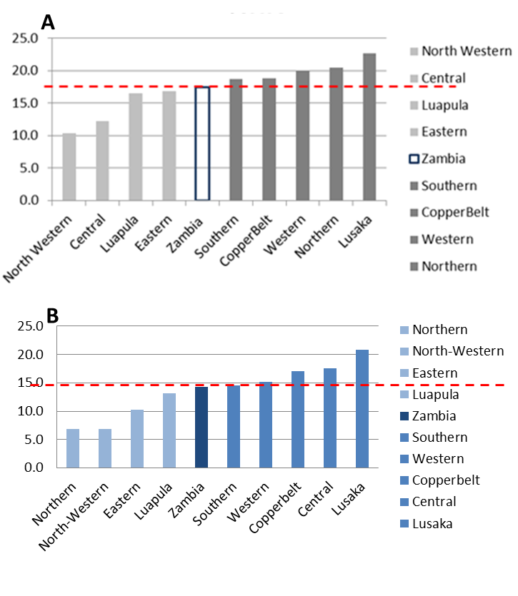
Fig. S1. Comparison of HIV prevalence in each province in Zambia with the national HIV prevalence. A) based on the 2011 HIV sentinel surveillance from antenatal clinics (HSS-ANC) [1] and B) based on the 2007 Demographic and Health Survey (DHS) [2].

References
1. Vandament L. Zambia 2011 HIV sentinel surveillance data from antenatal clinics. Country-level Data, Lusaka, Zambia 2013.
2. Zambia Demographic and Health Survey 2007. Available: http://dhsprogram.com/pubs/pdf/FR211/FR211%5Brevised-05-12-2009%5D.pdf [Internet]. CSO and Macro International Inc. 2009.

