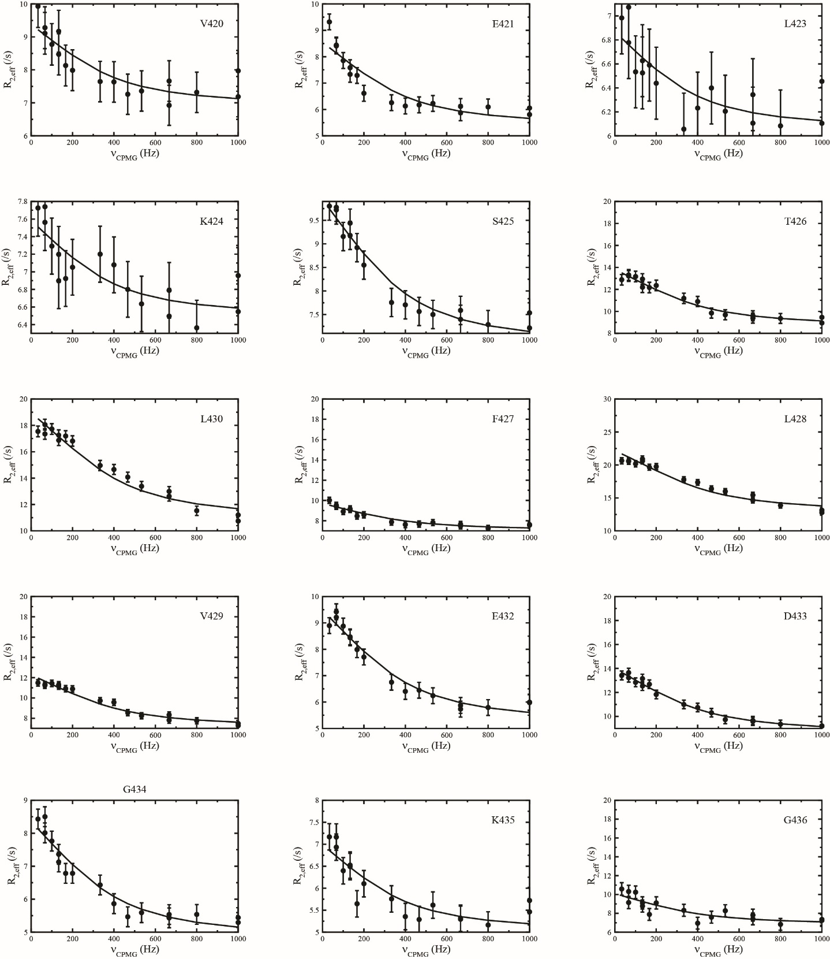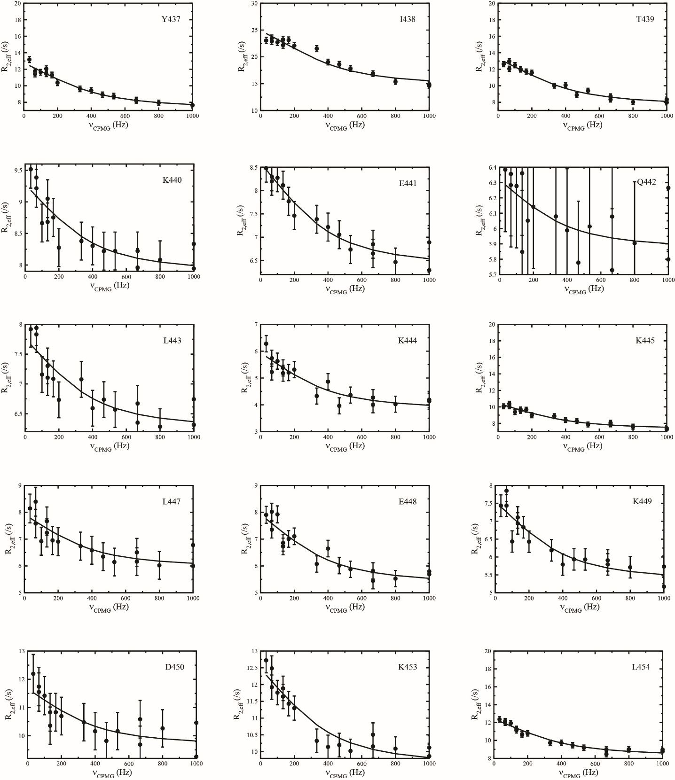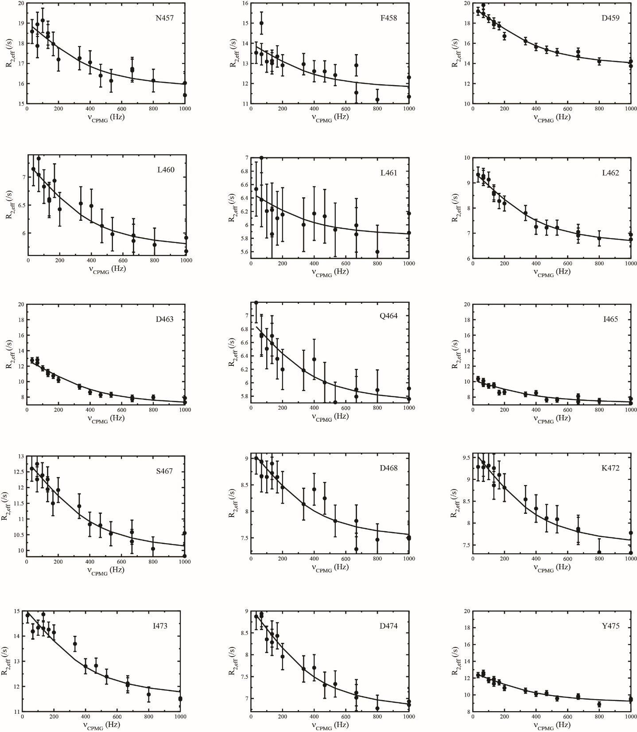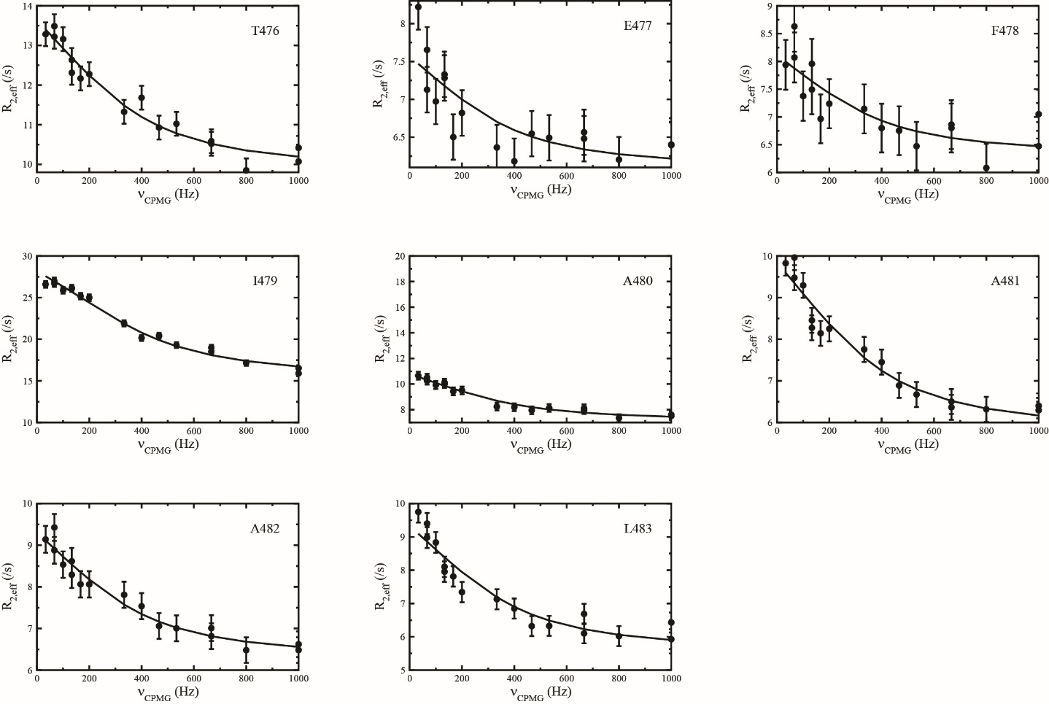
S3 Fig. ¹⁵N CPMG dispersions for CLD N-lobe^{Ca} at 600 MHz and 25°C. Filled circles represent experimental data and solid lines are the best fit to a global two-state model. Data for all residues with significant conformational dynamics (p<0.01) are shown.

