Colonization of a deglaciated moraine: contrasting patterns of carbon uptake and release from C3 and CAM plants
Elisa Varolo, Damiano Zanotelli, Leonardo Montagnani, Massimo Tagliavini, Stefan Zerbe

Supplemental material S1
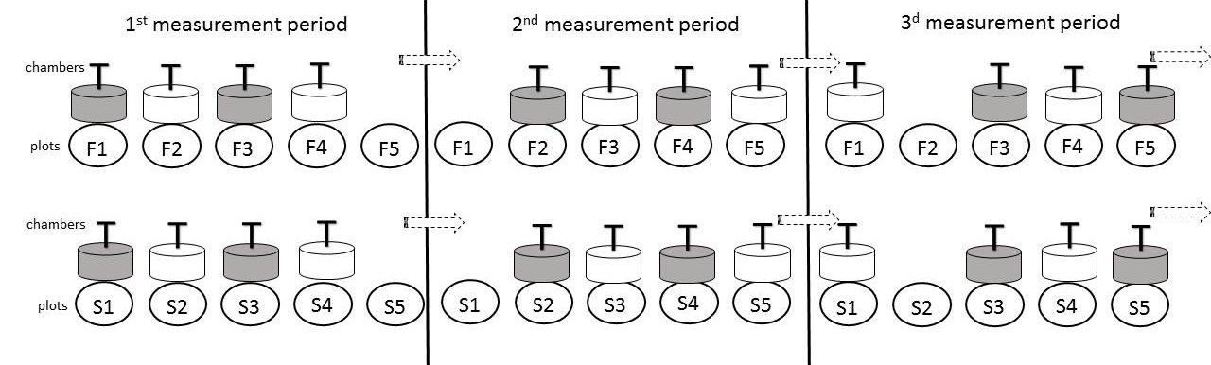
S1 Fig. Example of the experimental setup in 2012. Only the set-up used during the first three measurement periods is shown. Each measurement period lasted three days.

