Appendix S2 – Additional figures and tables
Table A1: Example longitudinal data structure (using hypothetical data)
Woman | Year | First child | Years since first child | Second child | Years since second child | Publications | Citations
1 | 1995 | 0 | 0 | 0 | 0 | 1 | 0
1 | 1996 | 0 | 0 | 0 | 0 | 0 | 1
1 | 1997 | 0 | 0 | 0 | 0 | 0 | 4
1 | 1998 | 0 | 0 | 0 | 0 | 0 | 0
1 | 1999 | 0 | 0 | 0 | 0 | 5 | 3
1 | 2000 | 0 | 0 | 0 | 0 | 5 | 4
1 | 2001 | 0 | 0 | 0 | 0 | 3 | 12
1 | 2002 | 0 | 0 | 0 | 0 | 2 | 12
1 | 2003 | 0 | 0 | 0 | 0 | 2 | 17
1 | 2004 | 1 | 0.083333 | 0 | 0 | 6 | 19
1 | 2005 | 1 | 1.083333 | 0 | 0 | 9 | 12
1 | 2006 | 1 | 2.083333 | 0 | 0 | 2 | 24
1 | 2007 | 1 | 3.083333 | 1 | 0.75 | 1 | 22
1 | 2008 | 1 | 4.083333 | 1 | 1.75 | 4 | 33
1 | 2009 | 1 | 5.083333 | 1 | 2.75 | 4 | 14
1 | 2010 | 1 | 6.083333 | 1 | 3.75 | 2 | 33
1 | 2011 | 1 | 7.083333 | 1 | 4.75 | 2 | 35
1 | 2012 | 1 | 8.083333 | 1 | 5.75 | 5 | 55
1 | 2013 | 1 | 9.083333 | 1 | 6.75 | 7 | 43
1 | 2014 | 1 | 10.08333 | 1 | 7.75 | 8 | 33
1 | 2015 | 1 | 11.08333 | 1 | 8.75 | 5 | 44

Table A2: Four predictors used to model the impact of caring for children on publication and citation counts over time
Predictor | Description
Caring for one child | Fixed change after first child
Caring for two children | Fixed change after second child
Years since care began for first child | Time-varying change after first child
Years since care began for second child | Time-varying change after second child

Figure A1: Example plot of model structure showing time and the four predictors in Table A2. In this example years since caring for first and second child have a linear effect, but this could be non-linear using the fractional polynomial approach.

Figure A2: Influential diagnostics for models of citations and papers using two children. The blue dot shows the estimates without participant 29 who is influential on citations counts and to a lesser degree paper counts.

Figure A3: Influential diagnostics for models of numbers of authors, affiliations and countries using two children. The blue dot shows the estimates without participant 29 and the green dot participant 57 who are influential on all three outcomes.

Figure A4: Influential diagnostics for models of first and last author using two children. The blue dot shows the estimates without participant 43 who is influential on the probability of being first author. The model for last author only included one child.

Figure A5: Estimated probability of being last author for women caring for two children and women caring for none after leaving out one statistically influential woman. Estimates for women whose careers started in 1995. Compare with Fig 3.

Table A3: Estimated model parameters (log or logit scale) for women caring for two children after removing statistically influential women.
Outcome | Predictor | Mean | 95% CI | P-value
Publications | First child, time-fixed | 0.18 | 0.00 to 0.37 | 0.053
(log scale) | Second child, time-fixed | 0.00 | –0.18 to 0.19 | 0.96
 | First child, time-varying | 0.41 | 0.24 to 0.59 | <0.001
 | Second child, time-varying | –0.51 | –0.66 to –0.36 | <0.001
Citations | First child, time-fixed | 0.57 | 0.49 to 0.64 | <0.001
(log scale) | Second child, time-fixed | 0.08 | 0.02 to 0.14 | 0.015
 | First child, time-varying | 0.02 | –0.05 to 0.1 | 0.55
 | Second child, time-varying | –0.41 | –0.47 to –0.34 | <0.001
Authors | First child, time-fixed | 0.10 | 0.01 to 0.19 | 0.026
(log scale) | Second child, time-fixed | –0.04 | –0.13 to 0.04 | 0.30
 | First child, time-varying | –0.09 | –0.22 to 0.03 | 0.14
 | Second child, time-varying | 0.12 | 0.02 to 0.23 | 0.019
Affiliations | First child, time-fixed | 0.17 | 0.02 to 0.32 | 0.025
(log scale) | Second child, time-fixed | 0.00 | –0.13 to 0.14 | 0.97
 | First child, time-varying | –0.08 | –0.24 to 0.07 | 0.28
 | Second child, time-varying | 0.07 | –0.07 to 0.20 | 0.33
Countries | First child, time-fixed | 0.54 | 0.13 to 0.95 | 0.010
(log scale) | First child, time-varying | –0.52 | –0.85 to –0.18 | 0.002
First author | First child, time-fixed | 0.31 | –0.05 to 0.67 | 0.09
(logit scale) | Second child, time-fixed | –0.29 | –0.65 to 0.07 | 0.12
 | First child, time-varying | –0.01 | –0.62 to 0.61 | 0.96
 | Second child, time-varying | –0.16 | –0.75 to 0.44 | 0.61

Figure A6: Parameter estimates and 95% confidence intervals (log-scale) for citation and paper numbers for complete case and multiply imputed data. The wider confidence intervals for the imputed data reflect the uncertainty caused by the missing child care data.
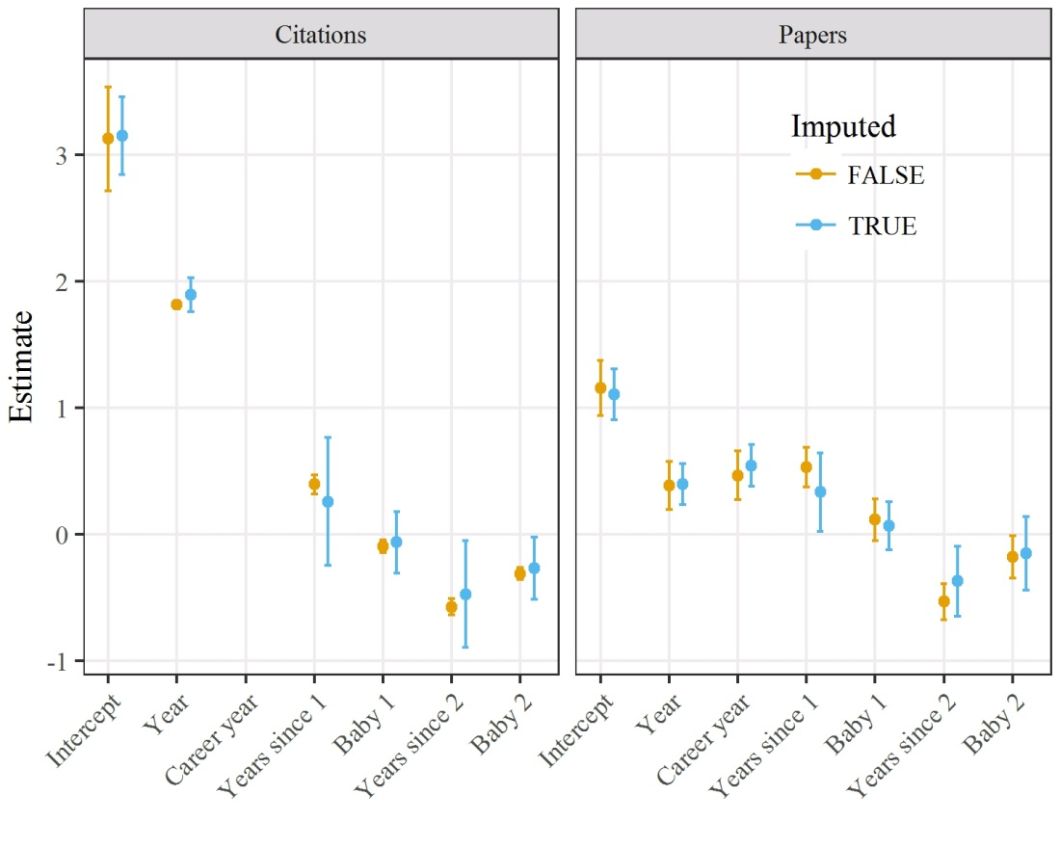
Figure A7: Parameter estimates and 95% confidence intervals for author, affiliation and country numbers (log-scale) for complete case and multiply imputed data. The wider confidence intervals for the imputed data reflect the uncertainty caused by the missing child care data. The imputed results for affiliation numbers are generally closer to the null.
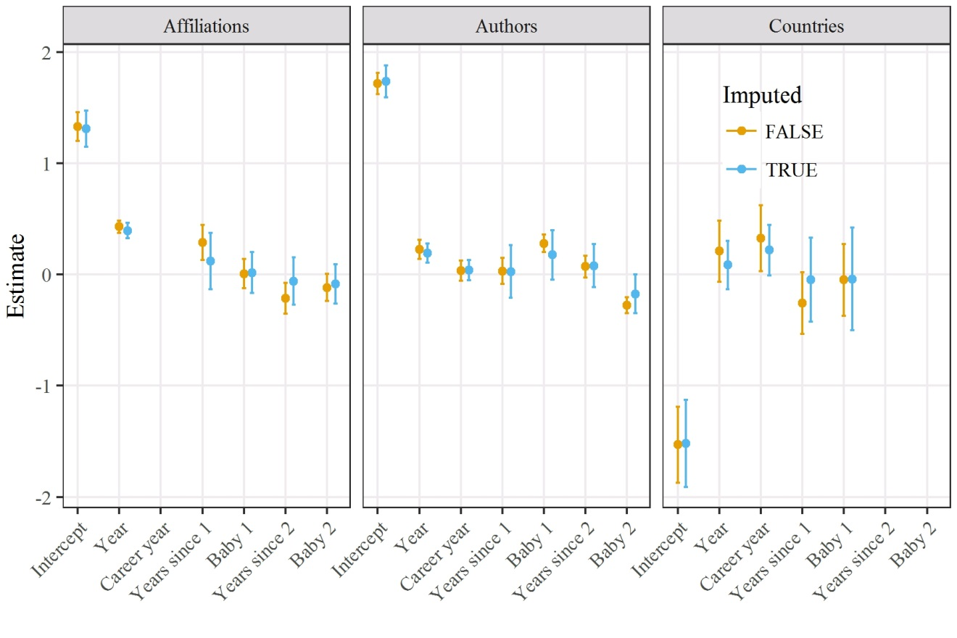

Figure A8: Parameter estimates and 95% confidence intervals for probability of being first or last author (logit-scale) for complete case and multiply imputed data.
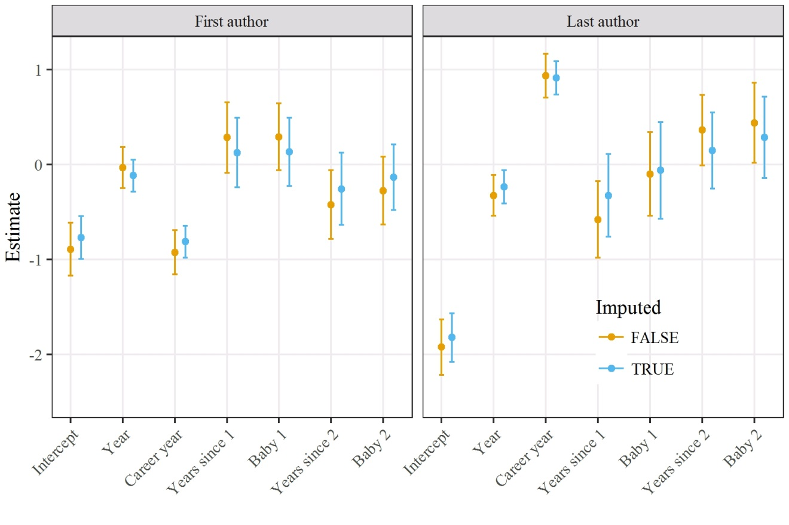

Figure A9: Estimated number of authors, affiliations and countries outside Australia per paper over time for women caring for two children and women caring for none using estimates that impute non-responders. Estimates for women whose careers started in 1995. Compare with Fig 2.

Figure A10: Histograms of total number of citations and publications for all 160 sampled women. The statistically influential participant 29 had the second highest number of total publications and citations.
Figure A11: Histograms of residuals for models of publication and citation numbers per year using two children. The histograms are approximately unimodal with no large outliers.

Figure A12: Histograms of residuals for models of author, affiliation and country numbers per paper using two children. The histograms are approximately unimodal with no large outliers.

Table A4: Akaike information criteria (AIC) for fractional polynomials for models with one or two children. The model with a power of “None” has no time-dependent variables to model the impact of child care. The bolded AIC indicates the best combination of child numbers and fractional polynomial power. DNC = did not converge.
Child numbers | Power | Citations | Publications | Author numbers | Affiliation numbers | Country not Australia | First author | Last author
None | – | 22966.2 | 5277.7 | 27965.6 | 22573.9 | 5223.8 | 3993.9 | 3330.3
One | –2.0 | DNC | DNC | DNC | DNC | DNC | DNC | DNC
One | –1.0 | DNC | DNC | DNC | DNC | DNC | DNC | DNC
One | –0.5 | DNC | DNC | DNC | DNC | DNC | 3995.7 | DNC
One | 0.0 | 22953.4 | 5280.4 | DNC | 22574.1 | DNC | DNC | DNC
One | 0.5 | 22941.9 | 5276.8 | 27958.1 | 22573.7 | 5221.4 | 3994.5 | 3332.6
One | 1.0 | 22840.0 | 5277.3 | 27953.1 | 22573.7 | 5223.3 | 3995.0 | 3329.8
One | 2.0 | 22569.0 | 5281.4 | 27956.4 | 22572.5 | 5224.7 | 3995.6 | 3325.9
One | 3.0 | 22467.4 | 5281.5 | 27957.0 | 22565.8 | 5223.8 | 3995.6 | 3326.1
One | None | 22957.6 | 5279.7 | 27956.5 | 22572.1 | 5222.8 | 3994.8 | 3331.3
Two | –2.0 | DNC | DNC | DNC | DNC | DNC | DNC | DNC
Two | –1.0 | DNC | DNC | DNC | DNC | DNC | DNC | DNC
Two | –0.5 | DNC | DNC | DNC | DNC | DNC | DNC | DNC
Two | 0.0 | 22532.5 | DNC | DNC | DNC | DNC | DNC | DNC
Two | 0.5 | 22326.4 | 5256.7 | 27904.8 | 22553.1 | 5223.3 | DNC | DNC
Two | 1.0 | 22209.7 | DNC | 27901.7 | 22557.4 | DNC | 3991.9 | 3322.1
Two | 2.0 | 22074.4 | 5226.4 | 27912.5 | 22563.0 | DNC | 3990.5 | 3317.7
Two | 3.0 | 22082.3 | 5220.4 | DNC | 22557.0 | DNC | 3990.4 | DNC
Two | None | 22902.3 | 5275.6 | 27909.0 | 22572.1 | 5222.8 | 3994.8 | 3331.3

Table A5: Estimated model parameters (log or logit scale) for women caring for two children after imputing non-responders.
Outcome | Predictor | Mean | 95% CI
Authors | First child, time-fixed | 0.17 | –0.05 to 0.40
 | Second child, time-fixed | –0.17 | –0.35 to 0.00
 | First child, time-varying | 0.03 | –0.21 to 0.26
 | Second child, time-varying | 0.08 | –0.11 to 0.27
Affiliations | First child, time-fixed | 0.02 | –0.17 to 0.20
 | Second child, time-fixed | –0.09 | –0.26 to 0.09
 | First child, time-varying | 0.12 | –0.13 to 0.37
 | Second child, time-varying | –0.06 | –0.27 to 0.15

Output from generalised linear mixed models from R
Best model for publication counts
Generalized linear mixed model fit by maximum likelihood (Laplace Approximation) ['glmerMod']
Family: poisson ( log )
Formula: papers ~ year.c + career.year.c + stan + baby.flag + stan2 + baby.flag2 + (1 | num)
Data: baby

AIC BIC logLik deviance df.resid
5220.4 5261.3 -2602.2 5204.4 1222

Scaled residuals:
Min 1Q Median 3Q Max
-2.6498 -0.9285 -0.2769 0.7392 10.7211

Random effects:
Groups Name Variance Std.Dev.
num (Intercept) 0.6751 0.8217
Number of obs: 1230, groups: num, 95

Fixed effects:
Estimate Std. Error z value Pr(>|z|)
(Intercept) 1.15645 0.11091 10.427 < 2e-16 ***
year.c 0.38714 0.09680 3.999 6.35e-05 ***
career.year.c 0.46491 0.09885 4.703 2.56e-06 ***
stan 0.53230 0.08003 6.651 2.91e-11 ***
baby.flag 0.11545 0.08418 1.372 0.1702
stan2 -0.53277 0.07214 -7.385 1.52e-13 ***
baby.flag2 -0.18024 0.08635 -2.087 0.0368 *
---
Signif. codes: 0 ‘***’ 0.001 ‘**’ 0.01 ‘*’ 0.05 ‘.’ 0.1 ‘ ’ 1
Best model for citation counts
Generalized linear mixed model fit by maximum likelihood (Laplace Approximation) ['glmerMod']
Family: poisson ( log )
Formula: citations ~ year.c + stan + Baby.flag + stan2 + Baby.flag2 + (1 | num)
Data: baby

AIC BIC logLik deviance df.resid
22074.4 22110.2 -11030.2 22060.4 1223

Scaled residuals:
Min 1Q Median 3Q Max
-20.1805 -2.3743 -0.5361 1.7525 15.2899

Random effects:
Groups Name Variance Std.Dev.
num (Intercept) 4.077 2.019
Number of obs: 1230, groups: num, 95

Fixed effects:
Estimate Std. Error z value Pr(>|z|)
(Intercept) 3.12808 0.20953 14.93 < 2e-16 ***
year.c 1.81374 0.01631 111.24 < 2e-16 ***
stan 0.39339 0.03951 9.96 < 2e-16 ***
Baby.flag -0.09525 0.02677 -3.56 0.000373 ***
stan2 -0.57602 0.03277 -17.58 < 2e-16 ***
Baby.flag2 -0.31237 0.02480 -12.60 < 2e-16 ***
---
Signif. codes: 0 ‘***’ 0.001 ‘**’ 0.01 ‘*’ 0.05 ‘.’ 0.1 ‘ ’ 1
Best model for number of authors per paper
Generalized linear mixed model fit by maximum likelihood (Laplace Approximation) ['glmerMod']
Family: poisson ( log )
Formula: n_auth ~ year.c + career.year.c + stan + Baby.flag + stan2 + Baby.flag2 + (1 | num)
Data: author.data

AIC BIC logLik deviance df.resid
27901.7 27951.7 -13942.8 27885.7 3837

Scaled residuals:
Min 1Q Median 3Q Max
-3.6052 -1.0098 -0.3971 0.3493 30.6256

Random effects:
Groups Name Variance Std.Dev.
num (Intercept) 0.1288 0.3589
Number of obs: 3845, groups: num, 95

Fixed effects:
Estimate Std. Error z value Pr(>|z|)
(Intercept) 1.71609 0.04864 35.28 < 2e-16 ***
year.c 0.22496 0.04390 5.12 2.99e-07 ***
career.year.c 0.03383 0.04710 0.72 0.473
stan 0.03066 0.05927 0.52 0.605
Baby.flag 0.27975 0.03916 7.14 9.04e-13 ***
stan2 0.06972 0.05005 1.39 0.164
Baby.flag2 -0.27538 0.03678 -7.49 6.99e-14 ***
---
Signif. codes: 0 ‘***’ 0.001 ‘**’ 0.01 ‘*’ 0.05 ‘.’ 0.1 ‘ ’ 1
Best model for number of affiliations per paper
Generalized linear mixed model fit by maximum likelihood (Laplace Approximation) ['glmerMod']
Family: poisson ( log )
Formula: n_affils ~ year.c + stan + Baby.flag + stan2 + Baby.flag2 + (1 | num)
Data: author.data

AIC BIC logLik deviance df.resid
22553.1 22596.9 -11269.6 22539.1 3838

Scaled residuals:
Min 1Q Median 3Q Max
-3.260 -0.964 -0.343 0.432 80.271

Random effects:
Groups Name Variance Std.Dev.
num (Intercept) 0.1746 0.4179
Number of obs: 3845, groups: num, 95

Fixed effects:
Estimate Std. Error z value Pr(>|z|)
(Intercept) 1.328187 0.065020 20.427 < 2e-16 ***
year.c 0.429159 0.027952 15.353 < 2e-16 ***
stan 0.289162 0.080533 3.591 0.00033 ***
Baby.flag 0.006558 0.067181 0.098 0.92223
stan2 -0.214818 0.069651 -3.084 0.00204 **
Baby.flag2 -0.117748 0.061816 -1.905 0.05681 .
---
Signif. codes: 0 ‘***’ 0.001 ‘**’ 0.01 ‘*’ 0.05 ‘.’ 0.1 ‘ ’ 1
Best model for number of countries per paper
Generalized linear mixed model fit by maximum likelihood (Laplace Approximation) ['glmerMod']
Family: poisson ( log )
Formula: n_not.australia ~ year.c + career.year.c + n_auth.c + baby.flag + stan + (1 | num)
Data: author.data

AIC BIC logLik deviance df.resid
5221.4 5264.3 -2603.7 5207.4 3377

Scaled residuals:
Min 1Q Median 3Q Max
-4.7727 -0.5713 -0.3784 -0.2189 10.5882

Random effects:
Groups Name Variance Std.Dev.
num (Intercept) 0.8926 0.9448
Number of obs: 3384, groups: num, 94

Fixed effects:
Estimate Std. Error z value Pr(>|z|)
(Intercept) -1.52976 0.17422 -8.78 <2e-16 ***
year.c 0.20863 0.14062 1.48 0.1379
career.year.c 0.32570 0.15135 2.15 0.0314 *
n_auth.c 0.23770 0.00644 36.91 <2e-16 ***
baby.flag -0.04979 0.16401 -0.30 0.7615
stan -0.25913 0.14145 -1.83 0.0670 .
---
Signif. codes: 0 ‘***’ 0.001 ‘**’ 0.01 ‘*’ 0.05 ‘.’ 0.1 ‘ ’ 1

Best model for first author
Generalized linear mixed model fit by maximum likelihood (Laplace Approximation) ['glmerMod']
Family: binomial ( logit )
Formula: first.author ~ year.c + career.year.c + n_auth.c + Baby.flag +
stan + Baby.flag2 + stan2 + (1 | num)
Data: order

AIC BIC logLik deviance df.resid
3990.4 4046.7 -1986.2 3972.4 3828

Scaled residuals:
Min 1Q Median 3Q Max
-2.301 -0.605 -0.374 0.732 51.413

Random effects:
Groups Name Variance Std.Dev.
num (Intercept) 0.5333 0.7302
Number of obs: 3837, groups: num, 95

Fixed effects:
Estimate Std. Error z value Pr(>|z|)
(Intercept) -0.89133 0.14217 -6.269 3.62e-10 ***
year.c -0.03052 0.11087 -0.275 0.7831
career.year.c -0.92286 0.11855 -7.784 7.01e-15 ***
n_auth.c -0.38435 0.06874 -5.591 2.26e-08 ***
Baby.flag 0.29345 0.18010 1.629 0.1032
stan 0.28590 0.18903 1.512 0.1304
Baby.flag2 -0.27304 0.18172 -1.503 0.1330
stan2 -0.42030 0.18383 -2.286 0.0222 *
---
Signif. codes: 0 ‘***’ 0.001 ‘**’ 0.01 ‘*’ 0.05 ‘.’ 0.1 ‘ ’ 1

Best model for last author
Generalized linear mixed model fit by maximum likelihood (Laplace Approximation) ['glmerMod']
Family: binomial ( logit )
Formula: last.author ~ year.c + career.year.c + n_auth.c + baby.flag +
stan + baby.flag2 + stan2 + (1 | num)
Data: order

AIC BIC logLik deviance df.resid
3317.7 3374.0 -1649.9 3299.7 3828

Scaled residuals:
Min 1Q Median 3Q Max
-2.035 -0.505 -0.277 -0.003 188.649

Random effects:
Groups Name Variance Std.Dev.
num (Intercept) 0.3525 0.5938
Number of obs: 3837, groups: num, 95

Fixed effects:
Estimate Std. Error z value Pr(>|z|)
(Intercept) -1.92265 0.14866 -12.933 < 2e-16 ***
year.c -0.32418 0.10975 -2.954 0.00314 **
career.year.c 0.93754 0.11841 7.917 2.42e-15 ***
n_auth.c -2.14888 0.12894 -16.666 < 2e-16 ***
baby.flag -0.09918 0.22465 -0.441 0.65887
stan -0.57861 0.20601 -2.809 0.00498 **
baby.flag2 0.44025 0.21533 2.045 0.04090 *
stan2 0.36514 0.18940 1.928 0.05387 .
---
Signif. codes: 0 ‘***’ 0.001 ‘**’ 0.01 ‘*’ 0.05 ‘.’ 0.1 ‘ ’ 1

