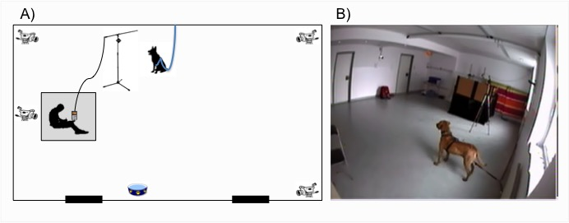

Figure S1. A) Upper view drawing of the recording room, B) Side view picture of the recording room.

