S9 Text: Effect Direction Plots – Alzheimer’s Disease and Dementia
Summaries in this appendix present findings for studies in patients with Alzheimer’s Disease and Dementia according to outcome and nature of effect (including direction and statistical significance). Findings for cross-sectional and sequential studies should be interpreted as associations not effects. Cells split into two colours indicate more than one analysis for the outcome with differing findings. These summaries are intended to provide a high-level comprehensive mapping of available data for this sub-population.
Systematic Reviews of Alzheimer’s Disease and Dementia: all outcomes
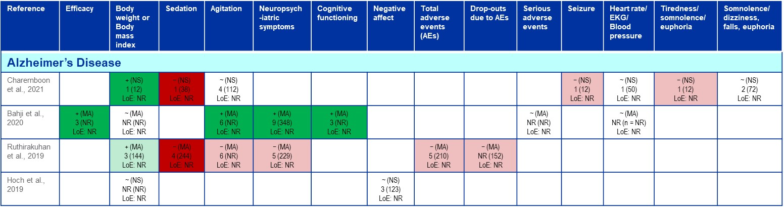

RCTs of Alzheimer’s Disease and Dementia: All Outcomes
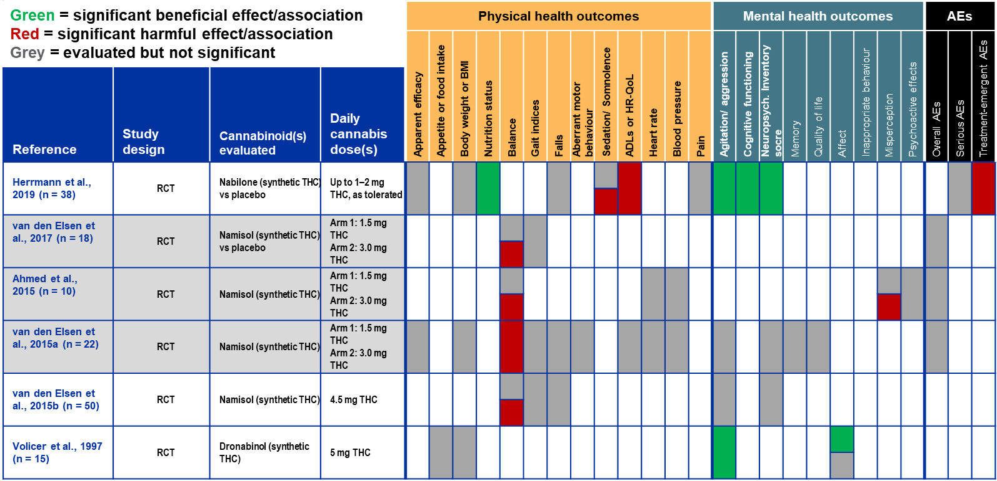

Non-randomized studies of Alzheimer’s Disease and Dementia: All Outcomes
