Table S3. Bioinformatic functional annotation of SNPs in high LD (r²>0.8 in AFR) identified in validated and new loci for incident coronary heart disease. Data obtained from HaploReg at www.broadinstitute.org/mammals/haploreg/haploreg.php
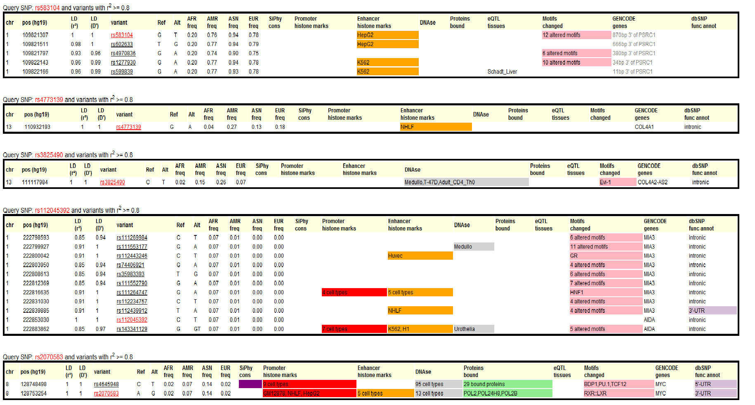
ed using R v2.15.1 (survival package), under an additive model.

