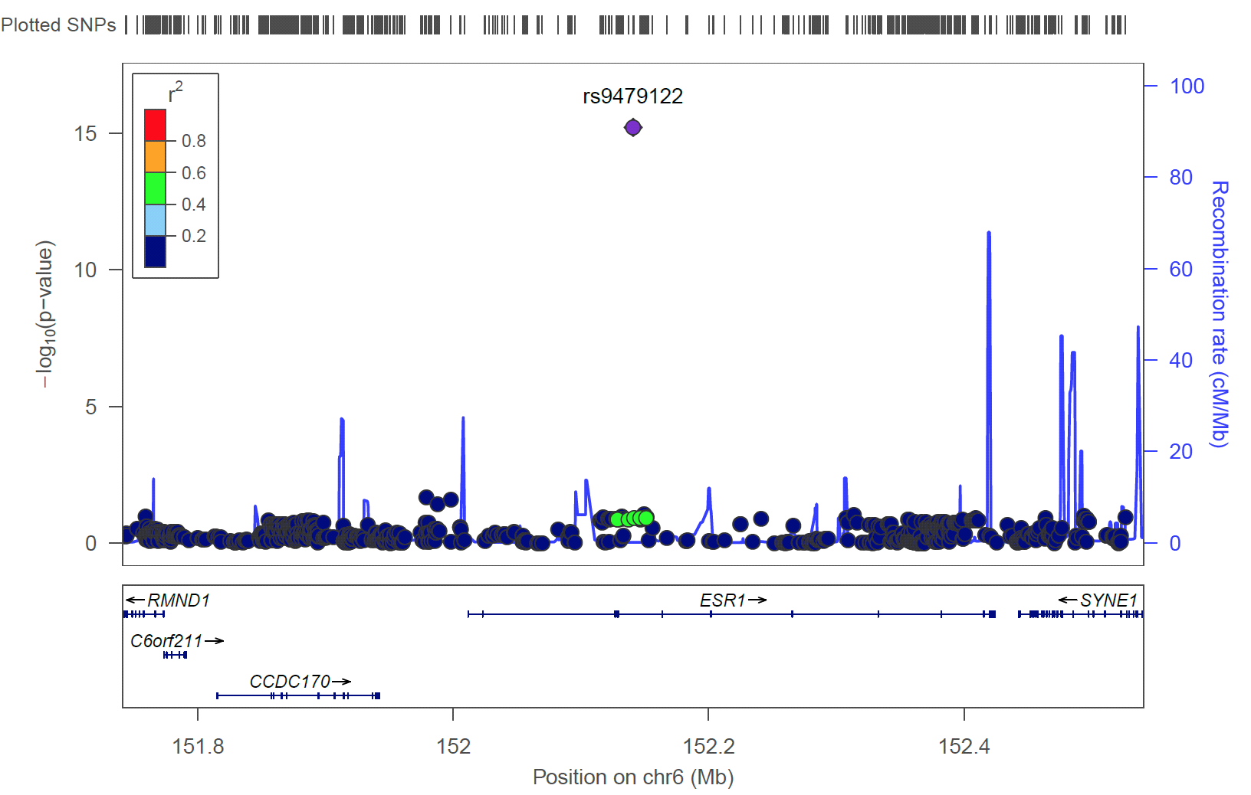
S5 Fig. LocusZoon plot of genome-wide significant result in ESR1 in European Americans with resistant hypertension versus controlled hypertensives. A genome-wide association study was performed for 1,719 European American cases of resistant hypertension and 708 controls from the eMERGE Network adjusted for sex, decade of birth, median body mass index, genotyping platform, and genetic ancestry (principal components 1-3). The left x-axis is the –log₁₀(p-value) of the tests of association and the right x-axis is the recombination rate (cM/Mb). The most significant result in European Americans (rs9479122) is plotted as the index variant color-coded as a purple diamond. Surrounding SNPs are circles color-coded by strength of linkage disequilibrium (LD calculated as r²), where red is complete or very strong LD and blue is weak LD or independent variants. LD was calculated using HapMap CEU data (release 22) in the default version of LocusZoom. Gene names and position on chromosome 6 (Mb) are given on the y-axis. The most significant finding (ESR1 rs9479122) is likely a false-positive due to poor genotyping prior to imputation and was removed.
We identified this potential genotyping and imputation error after performing a look-up for ESR1 rs9479122 in two independent datasets, INVEST [1, 2] and SPS3 [3]. INVEST was a large hypertension outcomes trial, and SPS3 was a secondary stroke prevention trial with a blood pressure arm. Both trials conducted genetic sub-studies and resistant hypertension phenotypes were constructed in a manner similar to that constructed in eMERGE. In INVEST and SPS3, ESR1 rs9479122 is nearly monomorphic (coded allele G frequency 0.996 and 0.99937, respectively), which is in agreement with HapMap CEU estimates.
ESR1 rs9479122 is imputed in this eMERGE dataset [4]. Prior to imputation, ESR1 rs9479122 was genotyped directly in eMERGE I on the Illumina 660W, and allele frequencies for this SNP are available for two studies genotyped in different batches: dementia [5] and the present resistant hypertension study. The allele frequency for the dementia study samples (0.9867; n=3,335) is similar to INVEST and SPS3; however, the allele frequency of the resistant hypertension study samples genotyped on the Illumina 660W (n=1,140) is drastically different (0.5008). Examination of the pre-quality control genotyping data for eMERGE I revealed that ESR1 rs9479122 produced genotypes in the Marshfield cataracts dataset [6] but at a call rate of 3%. No other pre-quality control eMERGE I datasets contained genotypes for ESR1 rs9479122, suggesting that this SNP targeted by Illumina 660W did not genotype well. ESR1 rs9479122 was targeted on Illumina BeadChips Human 370-Quad, 610-Quad, 660W-Quad, and 1M-Duo, but not on later chips.

References

1. Pepine CJ, Handberg EM, Cooper-DeHoff RM, et al. A calcium antagonist vs a non–calcium antagonist hypertension treatment strategy for patients with coronary artery disease: The international verapamil-trandolapril study (invest): a randomized controlled trial. JAMA. 2003;290(21):2805-16. doi: 10.1001/jama.290.21.2805.
2. Fontana V, McDonough CW, Gong Y, El Rouby NM, Sa AC, Taylor KD, et al. Large-scale gene-centric analysis identifies polymorphisms for resistant hypertension. J Am Heart Assoc. 2014;3(6):e001398.
3. The SPSSG. Blood-pressure targets in patients with recent lacunar stroke: the SPS3 randomised trial. The Lancet. 382(9891):507-15. doi: http://dx.doi.org/10.1016/S0140-6736(13)60852-1.
4. Verma SS, de Andrade M, Tromp G, Kuivaniemi H, Pugh E, Namjou-Khales B, et al. Imputation and quality control steps for combining multiple genome-wide datasets. Frontiers in Genetics. 2014;5:370.
5. McDavid A, Crane PK, Newton KM, Crosslin DR, McCormick W, Weston N, et al. Enhancing the Power of Genetic Association Studies through the Use of Silver Standard Cases Derived from Electronic Medical Records. PLoS ONE. 2013;8(6):e63481.
6. Ritchie MD, Verma SS, Hall MA, Goodloe RJ, Berg RL, Carrell DS, et al. Electronic medical records and genomics (eMERGE) network exploration in cataract: several new potential susceptbility loci. Mol Vis. 2014;20:1281-95.

