Fig S4: The graphs represent the partial effects of the significant predictors of the best model for (a) Chital and (b) Sambar using Generalized Additive Modeling with 95% confidence interval (grey shading). The ticks on the x axis represents the range of values for the variables in the surveyed area and the value within the parentheses on the y axis represents the effective degrees of freedom for each term.
a) Chital
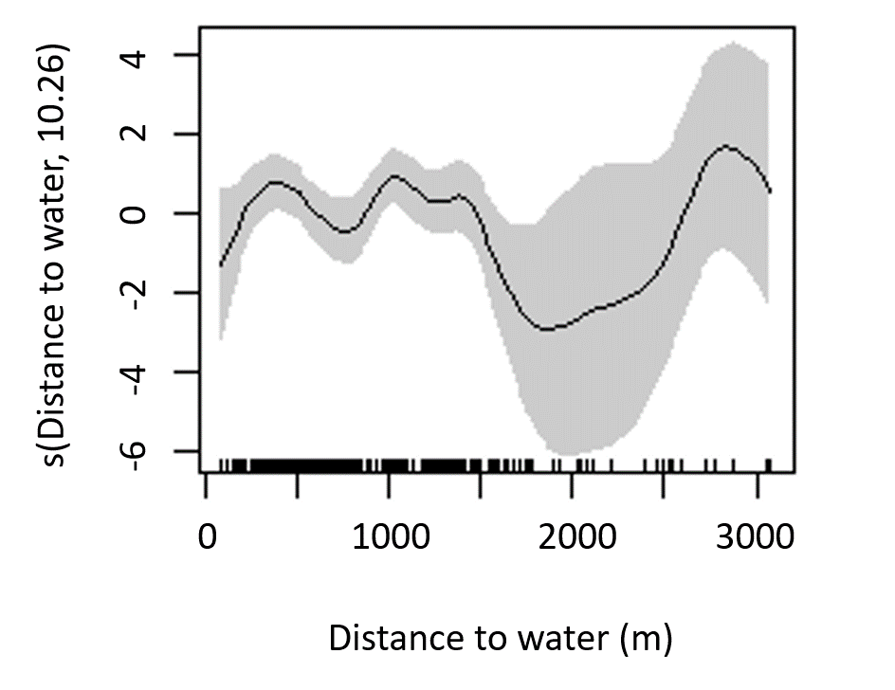

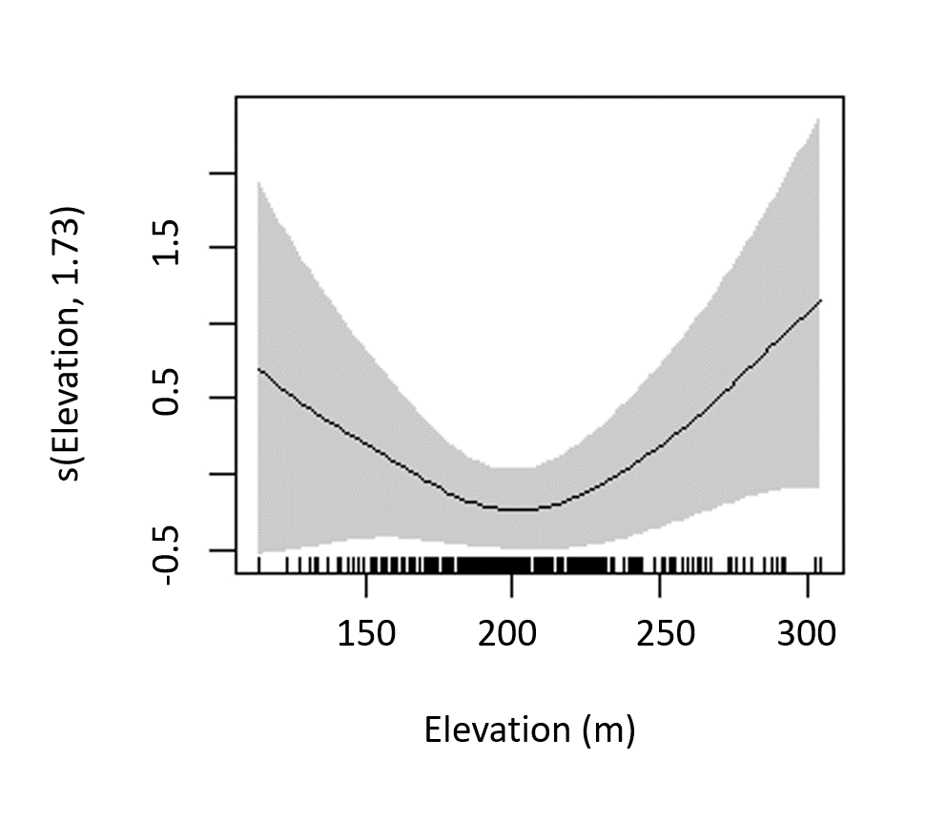
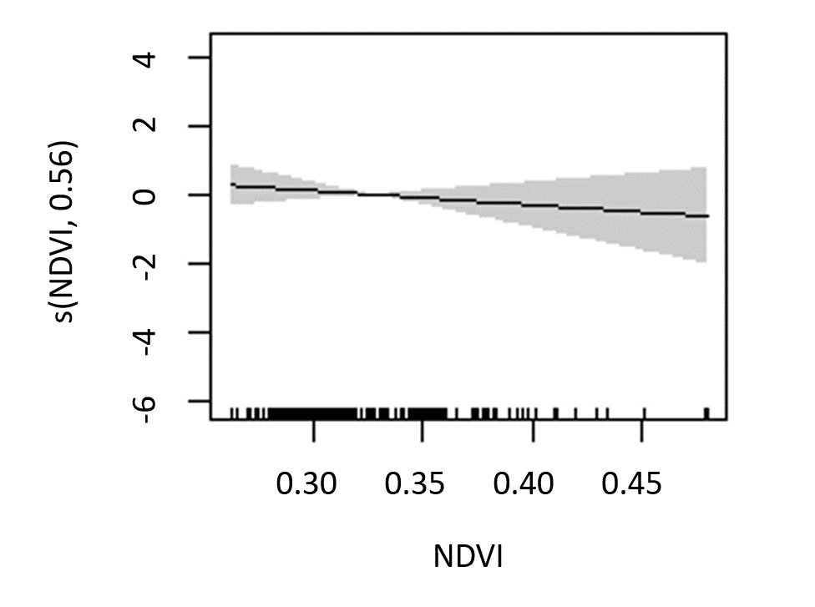

b) Sambar

