S1 Table. Identification of propolis samples from different regions of Bahia in Brazil analyzed in this study.
Geographic Identification | City and state of Brazil | Colour Type | Image
-14.863131, -40.552506 | Barra do Choça (Vitória da Conquista) – Bahia | Brown | 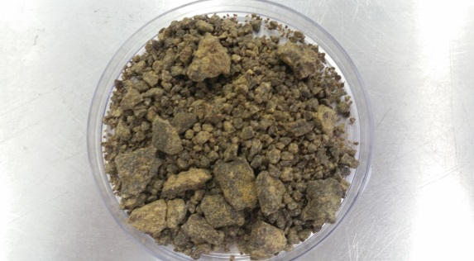
-14.863131, -40.552506 | Barra do Choça (Vitória da Conquista) – Bahia | Green | 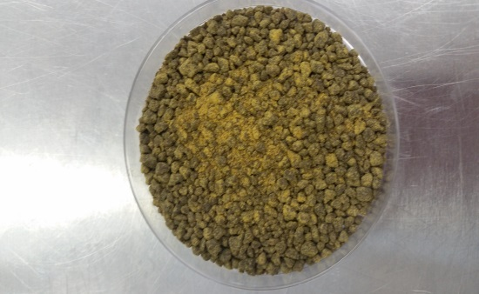
-15.669756, -38.952456 | Canavieiras – Bahia | Red | 