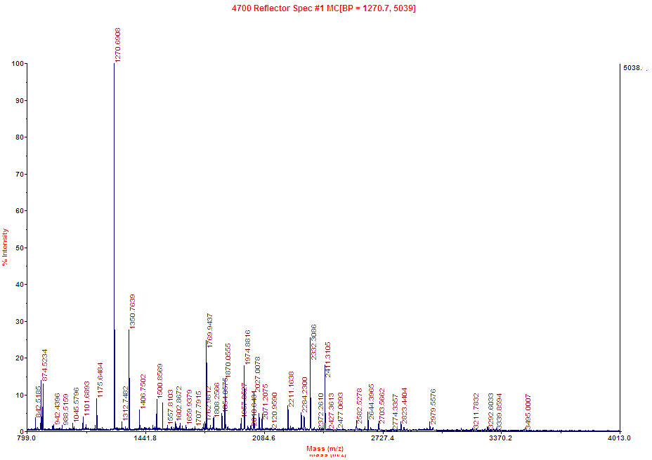
A

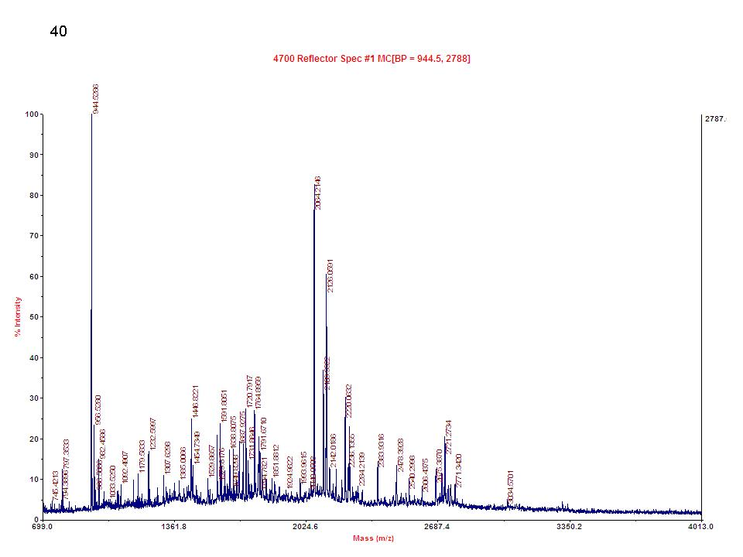
B

S8 Fig. Fragment patterns obtained in MALDI-TOF MS. (A) alpha-1-macroglobulin. (B) alpha-1-inhibitor 3. (provided by Genomine Inc.)

