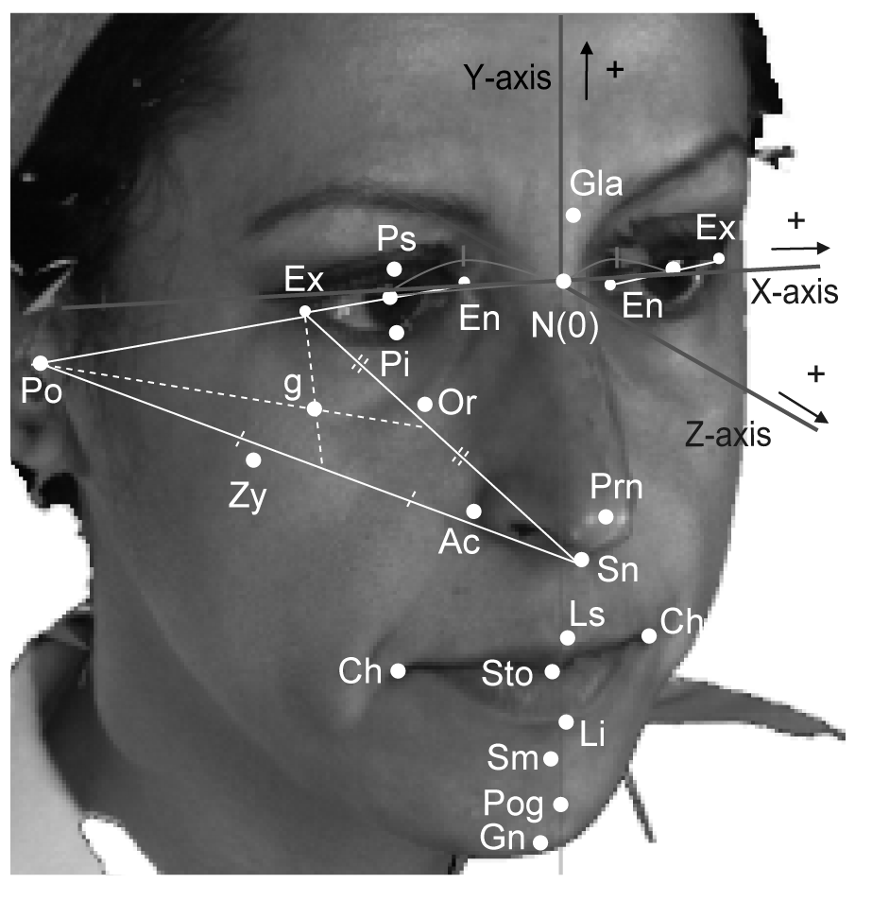
S1 Fig. The coordinate system and landmarks used in the present study. Please see S1 Table for the definitions of the landmarks (cited from Tanikawa et al., 2016 [11]).

