- Statistical Power Analyses for logistic regression from table 4 : Sex = Women

- Achieved power for α = 0.05, a sample size of 440 participants and a small effect size.
(Small effect size: Cohen’s d = 0.2 Odds ratio = 1.44)
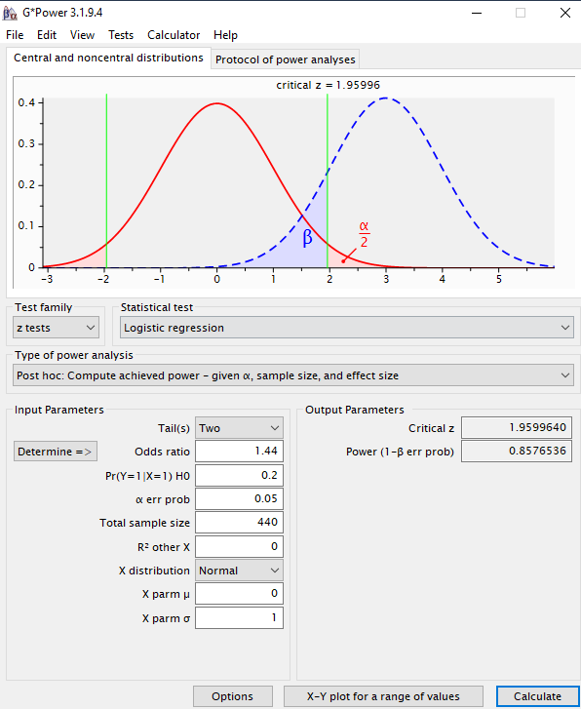
Figure 4. Achieved power for α = 0.05, a sample size of 440 participants and a small effect size.
Comment: For a small effect size, α = 0.05, a sample size of 440 participants, the achieved power was 85.8% for identifying predictors.

