S1 Appendix.
Table A. Occurrence of the ATPase and permease genes encoding the ABC-type membrane transporter putatively conferring reduced susceptibility to narasin in the vancomycin resistant Enterococcus faecium isolates from broilers included in this study.

Sample | Strain | Species | Results |  | Comment | VAN | NAR
 |  |  | ATPase  (476 bp) | Permease  (303 bp)
1 | 2006-01-1110 | broiler | + | + | VRE | R | RS
2 | 2006-01-1151 | broiler | + | + | VRE | R | RS
3 | 2006-01-1158 | broiler | + | + | VRE | R | RS
4 | 2006-01-1402 | broiler | + | + | VRE | R | RS
5 | 2006-01-2406 | broiler | + | + | VRE | R | RS
6 | 2006-01-2609 | broiler | + | + | VRE | R | RS
7 | 2006-01-3432 | broiler | + | + | VRE | R | RS
8 | 2006-01-3433 | broiler | + | + | VRE | R | RS
9 | 2009-01-1177-2 | broiler | + | + | VRE | R | RS
10 | 2009-01-1357-3 | broiler | + | + | VRE | R | RS
11 | 2009-01-1357-5 | broiler | + | + | VRE | R | RS
12 | 2009-01-1455-2 | broiler | + | + | VRE | R | RS
13 | 2009-01-1808-3 | broiler | + | + | VRE | R | RS
14 | 2009-01-1808-4 | broiler | + | + | VRE | R | RS
15 | 2009-01-1964-1 | broiler | + | + | VRE | R | RS
16 | 2009-01-2138-4 | broiler | + | + | VRE | R | RS
17 | 2009-01-2393-3 | broiler | + | + | VRE | R | RS
18 | 2009-01-2574-2 | broiler | + | + | VRE | R | RS
19 | 2009-01-2574-4 I | broiler | + | + | VRE | R | RS
20 | 2009-01-2807-2 | broiler | + | + | VRE | R | RS
21 | 2009-01-3361-2 | broiler | + | + | VRE | R | RS
22 | 2009-01-3896-4 | broiler | + | + | VRE | R | RS
23 | 2009-01-4415-2 | broiler | + | + | VRE | R | RS
24 | 2009-01-4530-4 | broiler | + | + | VRE | R | RS
25 | 2009-01-5505-5 | broiler | + | + | VRE | R | RS
26 | 2011-01-101-6 I | broiler | + | + | VRE | R | RS
27 | 2011-01-972-1 | broiler | + | + | VRE | R | RS
28 | 2011-01-1544-6 | broiler | + | + | VRE | R | RS
29 | 2011-01-1670-5 | broiler | + | + | VRE | R | RS
30 | 2011-01-2112-1 | broiler | + | + | VRE | R | RS
31 | 2011-01-2301-5 | broiler | + | + | VRE | R | RS
32 | 2011-01-2508-1 | broiler | + | + | VRE | R | RS
33 | 2011-01-2508-6 | broiler | + | + | VRE | R | RS
34 | 2011-01-3460-2 | broiler | + | + | VRE | R | RS
35 | 2011-01-3717-3 | broiler | + | + | VRE | R | RS
36 | 2011-01-3717-5 | broiler | + | + | VRE | R | RS
37 | 2011-01-3991-2 | broiler | + | + | VRE | R | RS
38 | 2011-01-3991-4 | broiler | + | + | VRE | R | RS
39 | 2011-01-4277-6 | broiler | + | + | VRE | R | RS
40 | 2011-01-5250-2 | broiler | + | + | VRE | R | RS
41 | 2011-01-5250-7 | broiler | + | + | VRE | R | RS
42 | 2011-01-5252-1 | broiler | + | + | VRE | R | RS
neg | Negative control |  | Ok | Ok
pos | Positive control |  | Ok | Ok
43 | 2011-01-5253-2 | broiler | + | + | VRE | R | RS
44 | 2011-01-5253-3 | broiler | + | + | VRE | R | RS
45 | 2011-01-5254-5 | broiler | + | + | VRE | R | RS
46 | 2011-01-5432-1 | broiler | + | + | VRE | R | RS
47 | 2011-01-5610-1 | broiler | + | + | VRE | R | RS
48 | 2011-01-6227-1 | broiler | + | + | VRE | R | RS
49 | 2011-01-6227-6 | broiler | + | + | VRE | R | RS
50 | 2011-01-6462-2 | broiler | + | + | VRE | R | RS
51 | 2011-01-6462-6 | broiler | + | + | VRE | R | RS
52 | 2011-01-6928-3 | broiler | + | + | VRE | R | RS
53 | 2011-01-6928-4 | broiler | + | + | VRE | R | RS
54 | 2011-01-6928-6 | broiler | + | + | VRE | R | RS
55 | 2011-01-7378-4 | broiler | + | + | VRE | R | RS
56 | 2011-01-7660-4 | broiler | + | + | VRE | R | RS
57 | 2011-01-7660-5 | broiler | + | + | VRE | R | RS
58 | 2011-01-7940-5 | broiler | + | + | VRE | R | RS
59 | 2011-01-7940-6 | broiler | + | + | VRE | R | RS
60 | 2011-01-8174-2 | broiler | + | + | VRE | R | RS
61 | 2011-01-8304-2 | broiler | + | + | VRE | R | RS
62 | 2011-01-8304-5 | broiler | + | + | VRE | R | RS
63 | 2011-01-8709-2 | broiler | + | + | VRE | R | RS
64 | 2011-01-9195-3 | broiler | + | + | VRE | R | RS
65 | 2011-01-9386-3 | broiler | + | + | VRE | R | RS
66 | 2014-01-1741 | broiler | + | + | VRE | R | RS
67 | 2014-01-1914 | broiler | + | + | VRE | R | RS
68 | 2014-01-2995 | broiler | + | + | VRE | R | RS
69 | 2014-01-4539 | broiler | + | + | VRE | R | RS
70 | 2014-01-6934 | broiler | + | + | VRE | R | RS
71 | 2014-01-7050 | broiler | + | + | VRE | R | RS
72 | 2014-01-7207 | broiler | + | + | VRE | R | RS
73 | 2014-01-7377 | broiler | + | + | VRE | R | RS
74 | 2014-01-7394 | broiler | + | + | VRE | R | RS
75 | 2014-01-7479 | broiler | + | + | VRE | R | RS
76 | 2014-01-7483 | broiler | + | + | VRE | R | RS
77 | 2014-01-7512 | broiler | + | + | VRE | R | RS
78 | 2014-01-7513 | broiler | + | + | VRE | R | RS
79 | 2014-01-7584 | broiler | + | + | VRE | R | RS
neg | Negative control |  | Ok | Ok
pos | Positive control |  | Ok | Ok
VRE; vancomycin resistant Enterococcus faecium, VAN; vancomycin, NAR; narasin, RS; Reduced susceptible

Figure A. Gel pictures showing PCR products of the ATPase gene of the vancomycin resistant isolates included in this study.

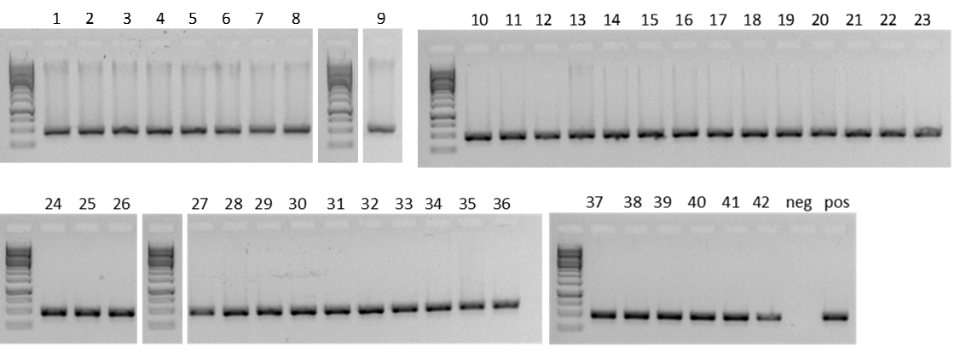

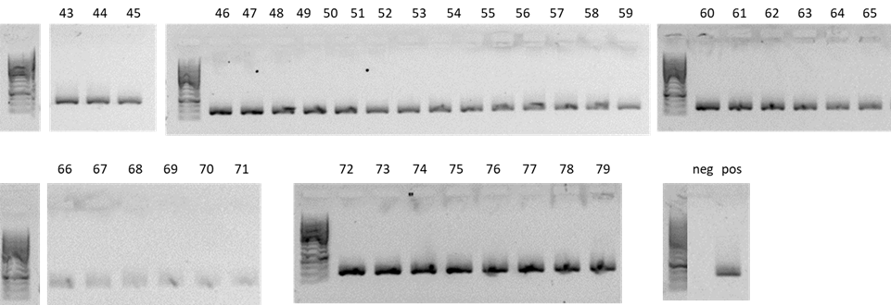

Figure B. Gel pictures showing PCR products of the permease gene of the vancomycin resistant isolates included in this study.

