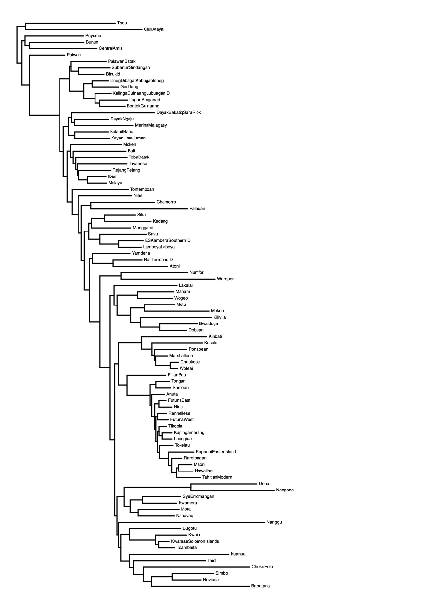
Fig. S1.
Phylogenetic tree used to extract the sister pairs used in our analyses. It is composed of all the languages included in Gray et al.³⁹ for which the Pulotu⁶⁹ database had an entry.

